* **SQL** is a language used for **relational databases** to query or get data out of a database. **SQL** is also referred to as **SQL** and is short for its original name **Structured Query Language**. So **SQL** is a language used for a database to query data.
* When Data is stored in a tabular form(columns and rows), it is called a **relational database**.
* After creating a **relational database** table and **inserting** data into the table, we want to see the data. To see the data, we use the **SELECT** statement.
* The **SELECT** statement is a **data manipulation language** statement. **Data Manipulation Language** statements or **DML** statements are used to read and modify data.
* The **SELECT** statement is called a query, and the output we get from executing this query is called a result set or a result table.  
  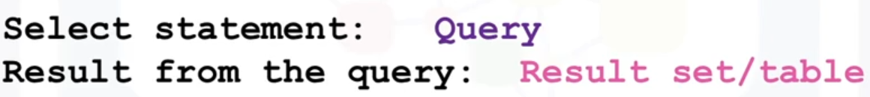
* The general syntax of **SELECT** statements is as follows. columns in the **result table** are in the order of their name written after the **select** statement, from left to right column1 then column2 then…  
  Syntax:  
  **select** COLUMN1, COLUMN2, ... **from** TABLE1 ;  
  ترجمه دستور بالا یعنی از جدول تیبل1 ستون های کالمن1 و کالمن2 و… را برگردان
* To retrieve all columns from the COUNTRY table we could use "*" instead of specifying individual column names:  
  **select** * **from** COUNTRY ;  
  اگر بخواهیم همه ستون های جدول را فرا بخوانیم از ستاره استفاده می کنیم
* **Select** statement’s output is a **table object**(kind of database object).
* The **WHERE** clause can be added to your **query** to filter results or get specific **rows** of data. To retrieve data for all rows in the COUNTRY table where the ID is less than 5:  
  **select** * **from** COUNTRY **where** ID < 5 ;  
  وِر شرط روی سطرهاست یعنی در خروجی سطرهایی را می خواهیم که دارای فُلان شرط (بعد از وِر) باشد
* In case of character-based **columns** the values of the predicates in the **where** clause need to be enclosed in single quotes. To retrieve the data for the country with country code "CA" we would issue:  
  **select** * **from** COUNTRY **where** CCODE = 'CA';
* The **WHERE** clause always requires a **predicate**. A **predicate** is conditioned evaluates to True, False or Unknown. **predicate** specifies a condition that is True, False, or Unknown about a given value, row, or group.  
   **Predicates** are used in the search condition of the **WHERE** clause.  
  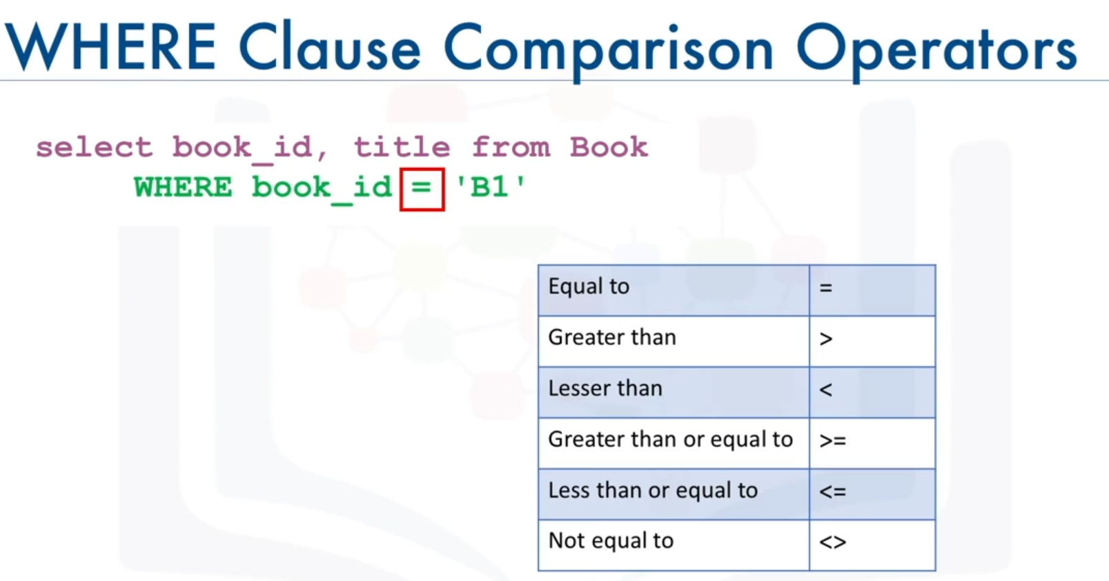

| **Operator** | **Description** |
| --- | --- |
| **=** | Equal |
| **>** | Greater than |
| **<** | Less than |
| **>=** | Greater than or equal |
| **<=** | Less than or equal |
| **<>** | Not equal. **Note**: In some versions of SQL this operator may be written as != |
| BETWEEN | Between a certain range |
| LIKE | Search for a pattern |
| IN | To specify multiple possible values for a column |

* **Select** syntax with all the above explanation is as follows:  
  Syntax:

**SELECT** column1, column2, ...

**FROM** table_name

**WHERE** condition

**;  
  
FROM**: Specifies from which table to get the data. The clause can include optional **JOIN** subclauses to specify the rules for joining tables.  
[Optional Clause] **WHERE** : Specifies which rows to retrieve.

* Some database systems require a **semicolon** at the end of each SQL statement for execution. It is a standard way to separate one SQL statement from another which allows more than one SQL statement to be executed in the same call to the server. So, it is good practice to use a **semicolon** at the end of each SQL statement.  
  اگر کوئری هایی که می زنیم مثلا روی یک جدول باشد و ما جداگانه کوئری بزنیم، دیتابیس یک بار از دیسک، داده ها را می خواند و کوئری ما را پاسخ می دهد. و نتیجه را برای ما ارسال می کند و حالا سراغ کوئری بعدی می رود و دوباره از دیسک، داده ها را می خواند. در صورتی که اگر هر دو کوئری را همزمان به دیتابیس می زدیم همان یک بار خواندن داده ها از دیسک برای پردازش هر دو کوئری کافی بود. پس بعضی وقت ها کوئری جداگانه اُورهِد دارد
* **SQL** requires **single quotes** around text values (most database systems will also allow double quotes).

However, **numeric** fields should **not** be enclosed in quotes:  
  
**SELECT** * **FROM** Customers

**WHERE** CustomerID=1**;**

* **Count:** The **COUNT(**) function returns the number of rows that matches a specified criteria. **COUNT** is a built-in database function that retrieves the number of rows that match the **query** criteria.  
  Syntax:  
  **SELECT** **COUNT**(column_name)

**FROM** table_name  
**WHERE** ;  
کانت یک شمارنده است. در سینتکس بالا ابتدا سطرها را با شرط **وِر** فیلتر می کند بعد آنها را می شمارد   


* Variations of the **count** **syntax** achieve different goals.

The **COUNT(*)** syntax allows us to count the number of rows in a table

The **COUNT**(**DISTINCT** column) syntax allows us to count the number of distinct values in a column

The **COUNT**(**CASE WHEN** condition **THEN** column **END**) syntax allows us to count the number of values that fulfill conditions.  
**COUNT()**, used with **GROUP BY**, is useful for counting the number of rows that belong to each group.

**COUNT()**, used with **HAVING**, is useful for filtering groups according to the number of rows they have.  
  
Read more: <https://www.datacamp.com/tutorial/count-sql-function>

* **DISTINCT** is used to remove duplicate values from a result set. The **SELECT DISTINCT** statement is used to return only distinct (different) values. Inside a table, a column often contains many duplicate values; and sometimes you only want to list the different (distinct) values.  
  Syntax:   
  **SELECT** **DISTINCT** column1, column2, ...

**FROM** table_name;  
We use following **syntax** to apply **scalar function** to distinct values of the **column**:  
Syntax: **select distinct**(**scalar_function**(column)) **from** table_name  
  
Example:   
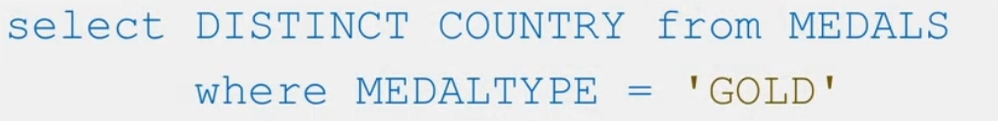

* **LIMIT** is used for restricting the number of rows retrieved from the database.  
   Syntax:   
  **SELECT** ColumName

**FROM** TableName

**LIMIT** number **Offset** value ; # **offset** value is optional  
  
-**ColumnName** is the name of the columns which you want to return in your output

**-TableName** is the name of the table from which you want to return the result set in your output

**-Offset** is the starting point. the number from which the result will display(starting point is at (value +1)). By default, the value is 0

The **number** is the number of records(rows) you want to display in the output  
Example 1: **SELECT** * **FROM** FilmLocations **LIMIT** 15 **OFFSET** 10;  
#It starts from row 11  
  
Example 2:   
  
فقط ده تا سطر اول از جدول را بر می گرداند  
  
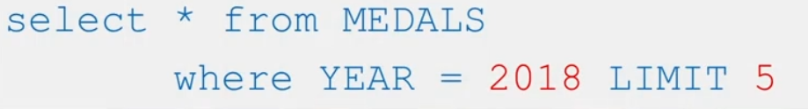  
Beware that **Limit** is located at the end of the statement.  
  
Read more about **limit**: <https://www.sqlshack.com/getting-started-with-sql-limit-clause/>

* **AVG()** and **SUM()** Functions are similar to **count().**Read more: <https://www.w3schools.com/sql/sql_count_avg_sum.asp>
* After the table is created, the table needs to be populated with data. To insert data into a table, we use the **INSERT** statement.The **INSERT** statement is used to add new rows to a table. The **INSERT** statement is one of the data manipulation language statements (**DML)**. **Data manipulation language** statements or **DML** statements are used to read and modify data. The **INSERT** **INTO** statement is used to insert new records(**rows**) in a table.
* It is possible to write the **INSERT INTO** statement in two ways:  
   1. Specify both the column names and the values to be inserted:  
   Syntax:   
    
   **INSERT INTO** table_name (column1, column2, column3, ...)

**VALUES**   
 (Value1, Value2,Value3,...) ,  
 (value1**,** value2**,** value3**,** ...) ;  
   
 2. If you are adding values for all the columns of the table, you do not need to specify the column names in the SQL query. However, make sure the order of the values is in the same order as the columns in the table. Here, the **INSERT INTO** syntax would be as follows:  
Syntax:   
**INSERT INTO** table_name

**VALUES** (value1**,** value2**,** value3**,** ...);  
  
[Geeks for Geeks](https://www.geeksforgeeks.org/sql-insert-statement/)

* It is also possible to only **insert** data in specific columns. DBMS inserts **null** for Those columns that are not mentioned in the statement.
* We can copy a table into another table with the **select** and **insert** statements.
* Tables do not need to be populated one row at a time, multiple rows can be **inserted** by specifying each row in the **values** clause. In the values clause, each row is separated by a comma. We can use both **insert** methods(mentioned above) for multiple row insertion. We just need to separate values with **comma.** We can write all values in one line.   
  Check each row in a separate line for a comma because without comma at the end, it doesn’t work.  
    
    
  Example:   
  **INSERT INTO** employee_details **VALUES**

('E40004','SANTHOSH','E102',25),

('E40005','THAMAN','E103',26),

('E40006','HARSH','E101',25),

('E40007','SAMHITH','E102',26);

* We use **comma** to separate items in different clauses like columns in **select** and values in **insert** statement
* The **UPDATE** statement is one of the **data manipulation language** or **DML** statements. DML statements are used to read and modify data.  
  To alter or modify the data in a table, we use the **UPDATE** statement.
* The **UPDATE** statement is used to modify the existing records(**rows**) in a table.  
  Syntax:   
  **UPDATE** table_name

**SET** column1 = value1**,** column2 = value2**,** ...

**WHERE** condition;

* Be careful when **updating** records(**rows**) in a table! Notice the **WHERE** clause in the **UPDATE** statement. The **WHERE** clause specifies which record(s) that should be updated. If you omit the **WHERE** clause, all records in the table will be updated!  
  It is the **WHERE** clause that determines how many records(rows) will be updated.  
  The following SQL statement will update the ContactName to "Juan" for all records where country is "Mexico":  
  **UPDATE** Customers

**SET** ContactName='Juan'

**WHERE** Country='Mexico';

* The **DELETE** statement is one of the **data manipulation language** statements used to read and modify data.
* The **DELETE** statement is used to delete existing records(rows) in a table.  
  Syntax:   
  **DELETE** **FROM** table_name **WHERE** condition;
* Be careful when deleting records in a table! Notice the **WHERE** clause in the **DELETE** statement. The **WHERE** clause specifies which record(s) should be deleted. If you omit the **WHERE** clause, all records in the table will be deleted!
* **String pattern**: In a relational database, we can use **string patterns** to search data rows that match this condition. For example, If we can't remember the name of the author, but we remember that their name starts with R, we use the **WHERE** clause with the **like** predicate. The **like** predicate is used in a **WHERE** clause to search for a pattern in a column.  
  The **percent sign %** is used to define missing letters. The **percent sign** can be placed before the pattern, after the pattern, or both before and after the pattern.  
  The **percent sign** is called a wildcard character. A wildcard character is used to substitute other characters. So, if we can't remember the name of the author, but we can remember that their first name starts with the letter R, we add the **like** predicate to the **WHERE** clause.   
  Syntax: **where** column_name **like** string_pattern   
    
  درواقع میگیم توی فلان ستون دنبال همچین پترن یا الگویی بگرد یا مقدار فلان ستون شبیه همچین الگویی باشد   
  For example:  
   **select** first_name **from** author  
   **where** firstname like 'R%';  
     
  This will return all rows in the author table whose author's first name starts with the letter R.
* **string patterns** are used for searching a **string** or a **sub-string** to find a certain character or group of characters from a string. We can use **LIKE** Operator of SQL to search sub-string. The **LIKE** operator is used with the **WHERE** Clause to search a pattern in string of column. The **LIKE** operator is used in conjunction with the two wildcards characters.

**-Percentage sign**( % ) : It represents zero, one or multiple characters of variable length.

**-Underscore** ( _ ) : It represents one, single character of fixed length.  
Example:   
**W__**: 3-character string that starts with w  
**%ra%**: string that contains “ra”   
هر چی می خواد قبل یا بعد از آر و اِی بیاد مهم نیست  
**%r**: string that ends in r.  
**r%:** string that start with r  
علامت درصد طول خاصی ندارد یعنی می تواند یک کاراکتر باشد یا بیشتر. یعنی طول استرینگ( که می خواهیم دنبالش بگردیم) را مشخص نمی کند ولی آندر اسکور طول مشخصی دارد و معادل یک کاراکتر است

* **BETWEEN** condition allows you to easily test if an expression is within a range of values (inclusive). The values can be text, date, or numbers. It can be used in a SELECT, INSERT, UPDATE, or DELETE statement. The SQL **BETWEEN** Condition will return the records where the expression is within the range of value1 and value2. **between** includes both boundary values(value1 and value2)  
  The **Between** operator is also used with the **WHERE** Clause.  
  Syntax:   
  **WHERE** column_name **BETWEEN** value1 **AND** value2
* We Use the **NOT** Operator with **BETWEEN:**Example:  **WHERE** Salary **NOT** **BETWEEN** 30000 **AND** 45000
* Actually we can use **greater than** or **lesser than** operators instead of **between** but **between** makes it easier and shorter to write queries: **Where** pages **BETWEEN** 290 **AND** 300equalsto   
  **where** pages>=290 **and** pages <=300
* **IN** operator allows you to easily test if the expression matches any value in the list of values. It is used to remove the need for multiple OR conditions in **SELECT**, **INSERT**, **UPDATE**, or **DELETE**. You can also use **NOT IN** to exclude the rows in your list. We should note that any kind of duplicate entry will be retained.  
  The **IN** operator is also used with the **WHERE** Clause.  
  Syntax:   
  **WHERE** column_name **IN** (list_of_values)  
  Example:   
  **Where** country **in** (‘AU’,’US’)  
    
   Actually **In** operator equals to many **or** operators. It’s easier to use **in** operator.  
    
  **Where** country **in** (‘AU’,’US’,’UK’) equals to  
   **Where** country= ‘AU’ **or** country=’US’ **or** country=’UK’  
  ترجمه این شرط می شود هرگاه مقدار کانتری یکی از این مقادیر بود مثلا آن سطر را در خروجی نشان بده یا بهتره به دیتابیس بگیم لطفا مقدار فلان ستون یکی از این مقادیر(لیست مقادیر) باشد
* **Like**, **Between** & **In** operators are condition operators so we use them with **where**. And they all have similar syntax:  
   **where** column_name **like/between/in** …  
  نام ستون قبل از این عملگرها میاد و بعدش هم که واضحه
* We can add more condition to **like** operator:   
  Sunyax: **where** col_name **like** pattern1 **or** pattern2 **and** pattern3
* The **ORDER BY** statement in SQL is used to **sort** the fetched data(alphabetically) in either ascending or descending according to one or more columns.

-By default **ORDER BY** sorts the data in ascending order.

-We can use the keyword **DESC** to sort the data in descending order and the  
 keyword **ASC** to sort in ascending order.  
  
Syntax:   
**SELECT** * **FROM** table_name **ORDER BY** column_name **ASC** یا **DESC**

Parameters:

table_name: name of the table.

column_name: name of the column according to which the data is needed to be arranged.

ASC: to sort the data in ascending order.

DESC: to sort the data in descending order.

#use either ASC or DESC to sort in ascending or descending order.  
  
Example:   
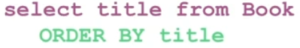

* **Order by** is used in **select** statements.
* Another way of specifying(مشخص کردن) the column to sort is to indicate the column sequence number. **Column sequence number** is a number that is assigned to columns in a **select** statement. Starts from 1. In the following query, **Column sequence numbe**r for title is 1 and for pages is 2.   
  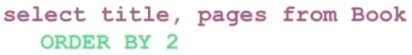  
  We can type either column name or column sequence number in **order by.  
  Syntax: Order by** Column_Number **asc/desc**We can write previous **query** example with column name**:  
    
  Select** title**,** pages **from** book **Order by** pages  
    
  شماره ستون ها به ترتیبی که در **سلکت** می آیند را می توان در **اُردر بای** استفاده کرد. در واقع به جای آنکه نام آن ستون را در**اُردربای** بنویسیم شماره آن را می نویسیم
* **Sort** according to multiple columns(using order by): In this example, we will fetch all data from the **table** Student and then **sort** the result in ascending order first according to the column Age. and then in descending order according to the column ROLL_NO.  
  Example:   
  **SELECT** * **FROM** Student **ORDER BY** Age **ASC** **,** ROLL_NO **DESC**;  
  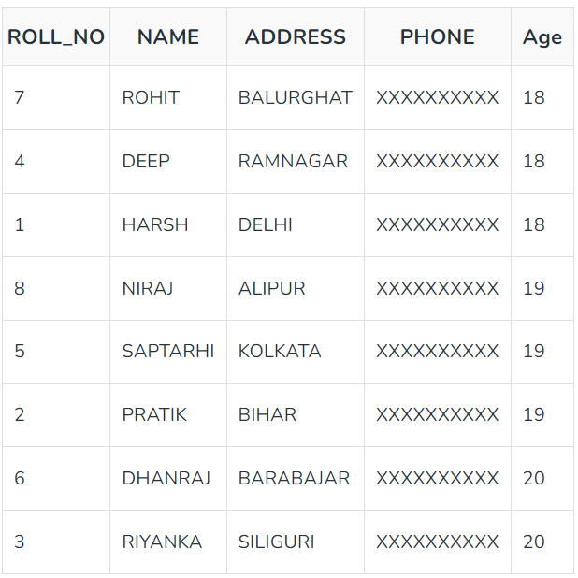  
  در صورتی می توان براساس دو تا ستون یا بیشتر مرتب سازی کرد که مرتب کردن **ستون دوم** در تناقض با مرتب کردن **ستون اول** نباشد (ترتیب **ستون اول** را بهم نزند).اینجا ابتدا ستون اِیج را مرتب می کنیم بعد ستون رول نامبر. مثلا اینجا ستون اِیج مقدار **تکراری** دارد ما مقادیر تکراری ستون اِیج را بر اساس معیار دوم که رول نامبر است مرتب می کنیم. جوری که همچنان ترتیب اِیج بهم نخورد. در ضمن ترتیب نام ستون ها بعد از **اُردر بای** اهمیت دارد و ستون ها به ترتیب نام آنها در **اُوردر بای** مرتب می شوند
* The **group by** clause groups a result into subsets(دسته،گروه) that have matching values(identical values) for one or more columns. **Group by** works based on a column or columns.
* The **GROUP BY** Statement in SQL is used to arrange identical data into groups with the help of some functions. i.e if a particular column has same values in different rows then it will arrange these rows in a group. Important Points:

-**GROUP BY** clause is used with the **SELECT** statement.

-In the query, **the GROUP BY** clause is placed after the **WHERE** clause.

-In the query, **GROUP BY** clause is placed before **ORDER BY** clause if used any.

-In the query , **the Group BY** clause is placed before the **Having** clause .

-we Place condition in the **having** clause  
  
Syntax:   
**SELECT** column1**,** **function_name**(column2)

**FROM** table_name

**WHERE** condition

**GROUP BY** column1**,** column2

**ORDER BY** column1**,** column2;

parameters:

function_name: Name of the function used for example, sum() , AVG(), count() and it will be applied to each group in the result set **separately**.

table_name: Name of the table.

condition: Condition used.

* **Group By** single column: **Group By** single column means, to place all the rows with the same value of only that particular column in one group.  
  **گروپ بای** روی یک ستون گروه ایجاد می کند به این صورت که همه مقادیر یکسان در آن ستون را در یک گروه قرار می دهد. یعنی **سطر** مربوط به این مقادیر یکسان را در یک گروه قرار می دهد
* **Group By** multiple columns: **Group by** multiple column is say for example, **GROUP BY** column1, column2. This means to place all the rows with the same values of both the columns column1 and column2 in one group.  
  Example: table student is as follows.  
  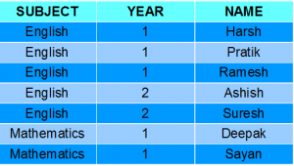  
    
    
  **SELECT** SUBJECT, YEAR, Count(*)

**FROM** Student

**GROUP BY** SUBJECT, YEAR;  
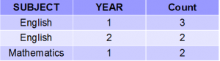  
As you can see in the above output the students with both the same SUBJECT and YEAR are placed in the same group. And those whose only SUBJECT is the same but not YEAR belong to different groups. So here we have grouped the table according to two columns or more than one column.

* The **AS** command is used to rename a **column** or **table** with an alias. An alias only exists for the duration of the **query**. We can use double quote **" "** orsingle quote **' '** for **aliases** or we can add nothing to them: "AVG_SALARY" or 'AVG_SALARY ' or AVG_SALARY  
    
  Alias for columns:  
  **SELECT** CustomerName **AS** Customer**,** ContactName **AS** [Contact Person]

**FROM** Customers;  
  
Alias for table:  
**SELECT** o.OrderID, o.OrderDate, c.CustomerName

**FROM** Customers **AS** c, Orders **AS** o  
  
Alias for table: We add **AS** to **From** clause   
Alias for columns: We add **AS** to **select** clause after column names.

* **HAVING Clause**: **HAVING** clause is used to apply a filter on the result of **GROUP BY** based on the specified condition. The conditions are **Boolean** type i.e. use of logical operators (AND, OR). This clause(having) has been included in SQL because the **WHERE** keyword fails when we use it with aggregate functions. **Having** is a very generally used clause in SQL. Similar to **WHERE** it helps to apply conditions, but **HAVING** works with groups. If you wish to filter a group, the HAVING clause comes into action. We can use **HAVING** clause to place conditions to decide which group will be part of the final result-set. Also we can not use the aggregate functions like **SUM()**, **COUNT()**,... with **WHERE** clause. So we have to use the **HAVING** clause if we want to use any of these functions in the conditions.  
  An aggregate expression(aggregate function) only can appear in the **select** list of columns or **HAVING** clause of a SELECT statement.  
    
    
    
  Syntax:   
  **SELECT** column1, **function_name**(column2)

**FROM** table_name

**WHERE** condition

**GROUP BY** column1, column2

**HAVING** condition

**ORDER BY** column1, column2;

Parameters:

function_name: Name of the function used for example, SUM() , AVG() and it will be applied to each group in the result set **separately**.

table_name: Name of the table.

condition: Condition used.

Example:  
   
**SELECT** dep_id

**FROM** EMPLOYEES

**group by** dep_id

**having** count(*)<4

**order by** 1;

* Order of Execution of SQL Queries is mentioned [here](https://www.geeksforgeeks.org/order-of-execution-of-sql-queries/).
* Some important points about **having** clause:

**-Having** clause is used to filter data according to the conditions provided.

-**Having** a clause is generally used in reports of large data.

-**Having** clause is only used with the SELECT clause.

-The expression in the syntax can only have constants.

-In the **query**, ORDER BY is to be placed after the HAVING clause, if any.

-**HAVING** Clause is implemented in column operation.

-**Having** clause is generally used after GROUP BY.

* When we use **group by**, **functions** (function_name) are applied to each group. For example sum, avg, count,...  
  If we don’t use **group by**, these **functions** are applied to all the rows of the column.
* While it is very much possible to first fetch data from a database and then perform operations on it from your applications and notebooks, most databases come with Built-in Functions. These functions can be included in **SQL** statements, allowing you to perform operations on data right within the database itself. Using database functions can significantly reduce the amount of data that needs to be retrieved from the database. That is, reduces network traffic and use of bandwidth. When working with large data sets, it may be faster to use built in functions, rather than first retrieving the data into your application and then executing functions on the retrieved data. Note that it is also possible to create your own functions, that is **User-Defined Functions** in the database;
* an **aggregate** function takes a collection of values, such as all of the values in a column, as input, and **returns** a single value or null. Examples: **sum**, **min**, **max**, **avg**, **count**, …  
    
  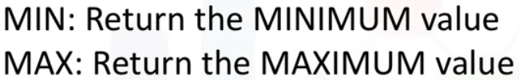

  
  
  
**Aggregate** functions can’t be used without a **select** statement. These **Functions** come immediately after **select** statement:  
  
**SELECT** column1, **function_name**(column2)  
  
#column1 is not necessary, it is an example.

* **Aggregate** Functions take a **column** as an input and **return** a single value as an output.
* When you use an **aggregate** function, the **column**(column name in output table) in the result set by default is given a **number**( has no name). We can use **as** keyword to give it an alias.
* **Aggregate** functions can also be applied on a subset of data instead of an entire **column**. We can use **where** clause to filter rows. We can also use **group by** (if there is a repeating value) but it applies the **function** to each group which is extra work. We just need the **minimum** of dogs. With the **group by,** it calculates the **minimum** for cats, dogs, goldfish,...  
  
* We can perform **mathematical operations**( **/**, **\***, **+**, **-** , ...) for each row between **columns of a row**, and then apply **aggregate** functions on them.  
  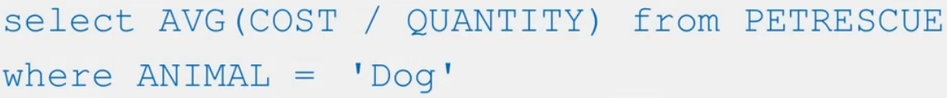  
  عملیات حسابی روی هر سطح انجام می دهد و نتیجه را به صورت یک ستون جدید در خروجی نشان میدهد  
  برای هر سطر مقدار **کاست** آن را بر مقدار **کوانتیتی** تقسیم می کند بعد از همه مقادیر **میانگین** می گیرد
* **Scalar** and **string** functions:   
  **Scalar**: performs operations on **every** input value(every value in a **column**). Such as Round(),...  
  **String** function: There is a **class of scalar** functions called **string** functions, that can be used for operations on strings. That is **char** and **varchar** values. Such as **UCASE**, **LCASE, LENGTH  
  Uppercase** and **lowercase** functions can be used to **return** uppercase or lowercase values of **strings**.  
  **Length** is used to retrieve the length of **string** in a **column**.
* **Scalar** functions can be used in the **where** clause. if you're not sure whether the values are stored in **upper**, **lower** or **mixed** case in the **table**, better to use **scalar** function such as **LCASE** in the **where** clause:

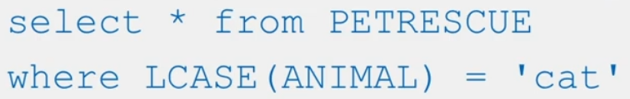

* We can use the **scalar** function as **input** for another function. We need to watch out for the **output** of the inner function **format** to be compatible as **input** of the second function. Some functions return a **column** as an **output, some** return a single value. To apply **scalar** function to distinct(unrepeated) values in a **column** we use **Distinct** and **scalar** functionsyntax:  
  **Select** **distinct**(**scalar_function**(column)) **from** table  
    
  **Aggregate** functions have different **syntax** for **distinct**. Check out **count** (**distinct …**)
* Output of **aggregate** function is a single value while output of **scalar** function is a column(not a single value).
* Most databases contain special data types for **dates** and **times**.  
  IBM db2 **date** and **time** data type:  
  **Date**: YYYYMMDD  
  **Time**: HHMMSS  
  **Timestamp**: YYYYXXDDHHMMSSZZZZZZ  
  **Times stamp** consists of **date**+**time**+**microseconds**(six Z). XX is month.
* **Functions** exist to extract the **day**, **month**, **day of month**, **day of week**, **day of year**, **week**, **hour**, **minute**, and **second**.  
  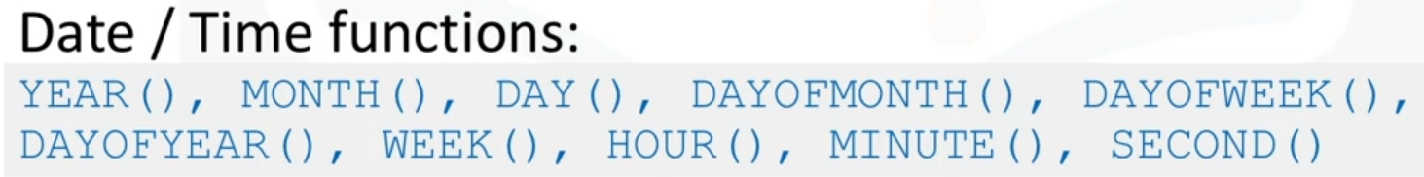  
  All the above functions are **scalar**. The **day** function can be used to extract the **day** portion from a **date**:  
    
  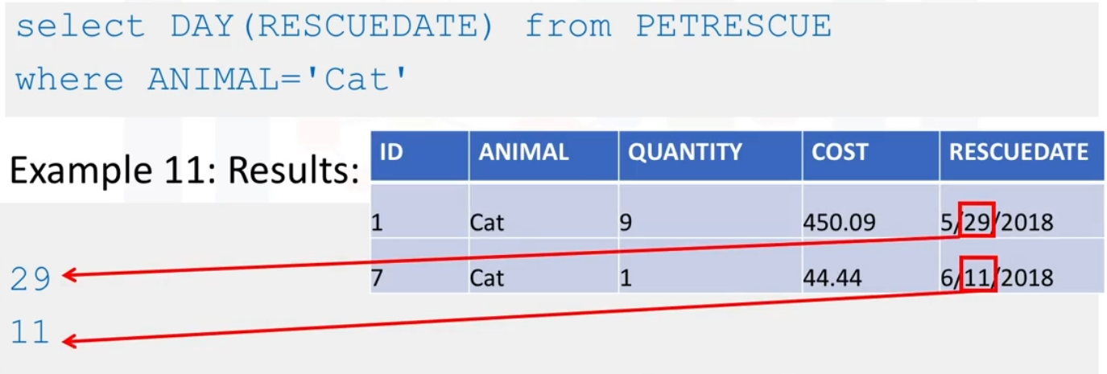  
  [Date and time functions for MySQL](https://dev.mysql.com/doc/refman/8.0/en/date-and-time-functions.html)
* **Date** and **time** functions can be used in the **where** clause.  
  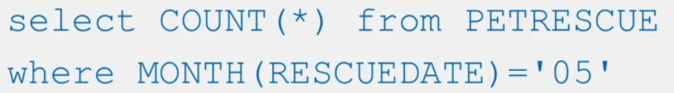  
  تعداد سطرهای جدول مربوط به **بُرج پنج** را بشمار
* You can also perform **date** or **time** arithmetic. For example, to find out what date it is three days after each date in the table.  
    
  می توان روی ستون مربوط به داده های زمانی یا تاریخ(دِیت و تایم) **عمل های حسابی** را انجام داد. مثلا **تاریخ** را به اضافه سه روز کنیم یا پنج **ماه** به آن اضافه کنیم یا از آن کم کنیم  
  **Days** in the above **query** is not a column. It is a built-in feature.  
  Output:  
  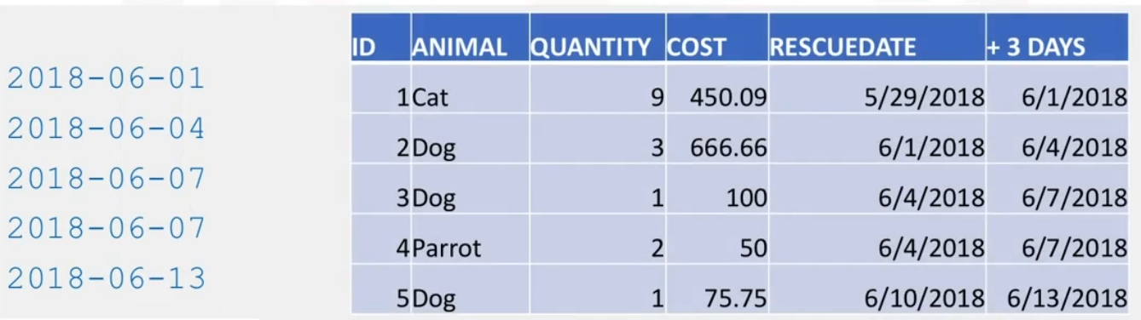
* Special registers **current_time** and **current_date** are also available.  
  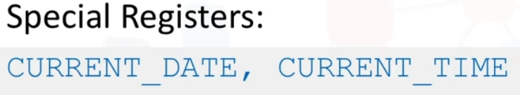  
  For example, to find how many days have passed since each rescue date till now:  
  
* **Sub-queries** or **nested** **select** statements: **Sub-queries** or **sub selects** are like regular **queries** but placed within parentheses and **nested** inside another **query**.  
    
  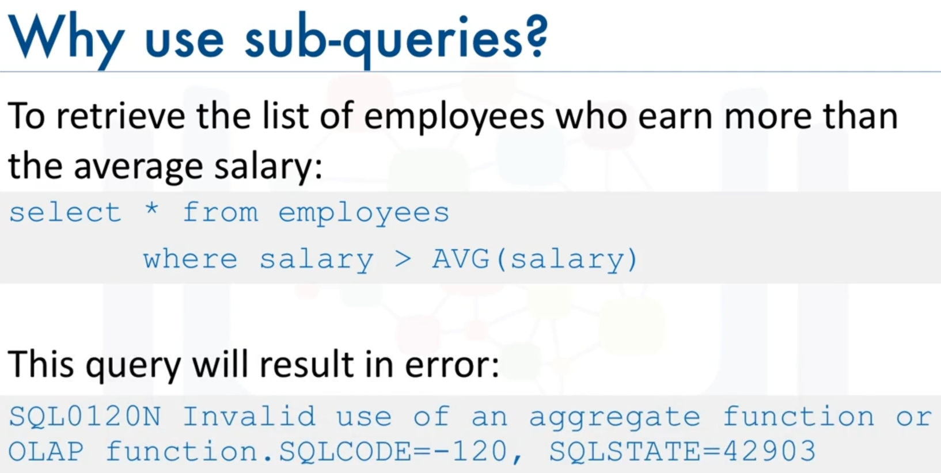  
  this **query** will result in an error like the one shown. Indicating an invalid use of the **aggregate** function.  
  One of the limitations of built-in **aggregate** functions, like the **average** function, is that they cannot always be evaluated in the **WHERE** clause. They have to be used with **select** statements or with **group by**.  
  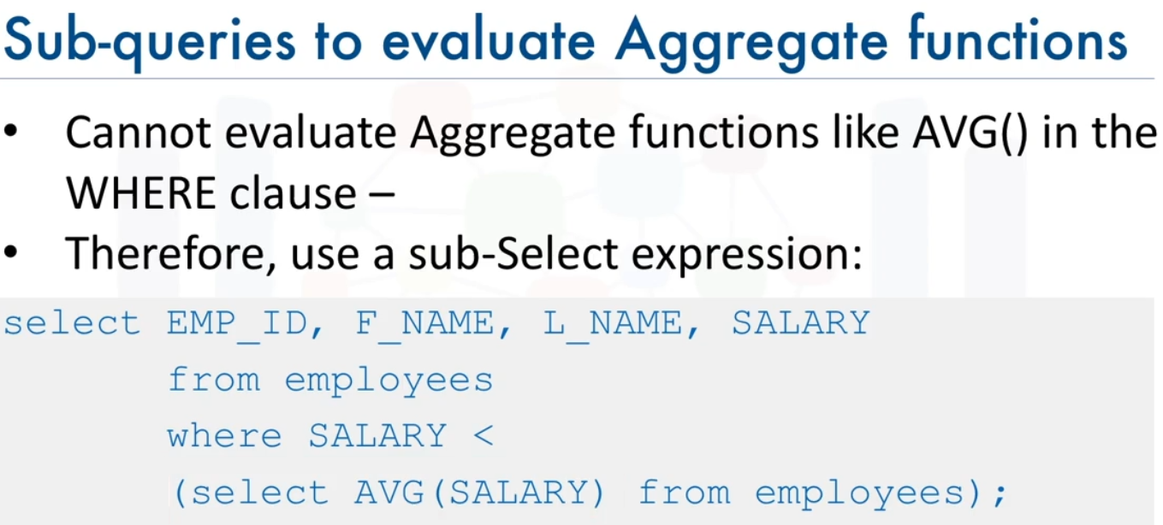  
    
  The **sub-select** doesn't just have to go in the **WHERE** clause. It can also go in other parts of the **query**, such as in the list of columns to be **selected**. Such **sub-queries** are called **column** **expressions**.  
    
    
  This **query** results in an error indicating that no **group by** clause is specified. **Aggregate** functions like **AVG** return a single value. We are placing a single value(AVG output) in the **select** column list which raises an error. We can solve this error by using the **average** function in a **sub-query** placed in the **list of the columns**.  
  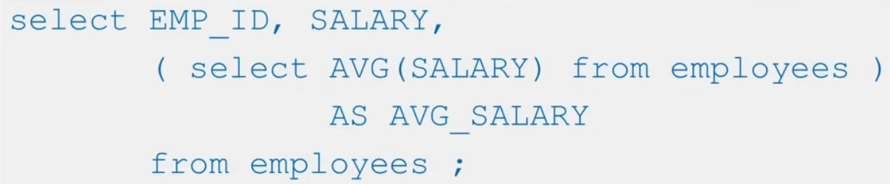  
  We replaced the **avg** column with a **sub-query**. **As** keyword is not inside **sub-query**.  
    
  Another option is to make the **sub-query** be part of the **FROM** clause. **Sub-queries** like these are sometimes called **derived tables** or **table expressions**. We use these **sub-queries** as a table in the **From** clause.  
  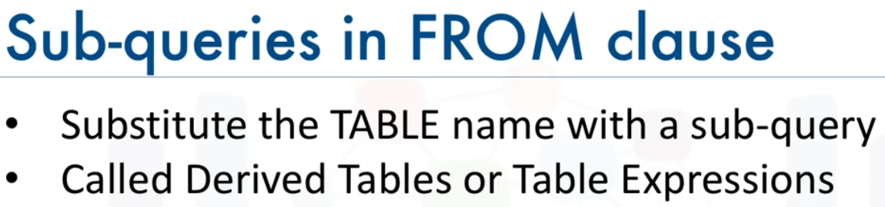
* You can place the **Subquery** in **HAVING** clause
* A **subquery** is a **query** within another **query**. The outer **query** is called main **query** and the inner **query** is called **subquery**.
* The **subquery** generally **executes** first(runs first) when the **subquery** doesn’t have any co-relation with the main **query**
* Use single-row operators(=, >, >=, <, <=, <>) with **single-row Subqueries**. Use multiple-row operators(ALL, IN, NOT IN, ANY) with **multiple-row Subqueries**.  
  A **single row subquery** returns one row to the outer SQL statement.
* **Subquery** must be enclosed in parentheses.
* **Subqueries** are on the right side of the **comparison operator**.
* We can use **IN** **operators** with **sub-queries:  
    
  Select** NAME, LOCATION, PHONE_NUMBER **from** DATABASE

**WHERE** ROLL_NO **IN**

(**SELECT** ROLL_NO **from** STUDENT **where** SECTION=’A’);

* We can use **sub-queries** to work with multiple **tables**. We use a **subquery** to retrieve(return) a column of a **table** then we use **IN** operator and that column (retrieved from subquery) in the **where** clause of the main query.  
  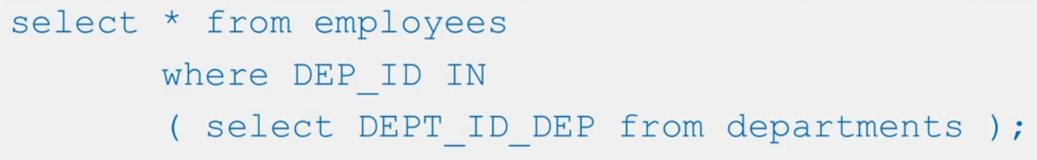  
  **Another example**:  
    
  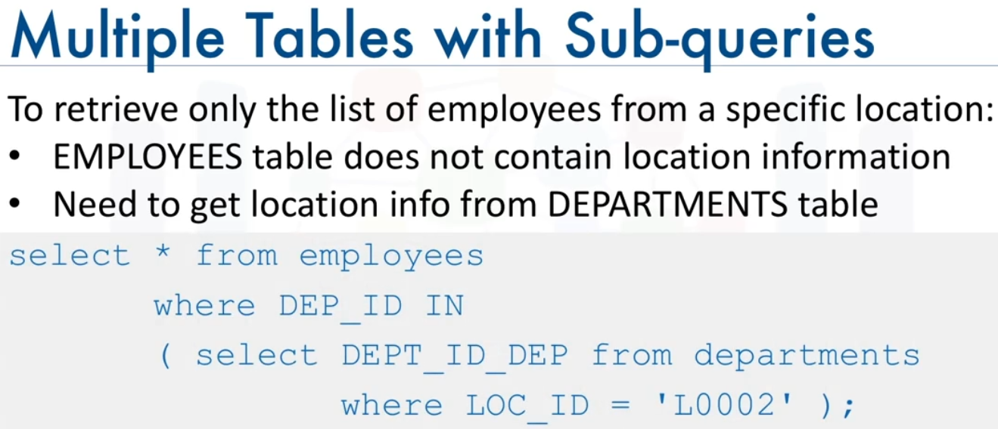
* We can also access multiple tables simultaneously by specifying them in the **FROM** clause of the **query**. We enter two or more tables in the **From** clause. Using two or more tables in a **From** clause results in **cross join** or **cartesian join** of all the tables.  
  This results in a **table join**, but note we are not explicitly using the **join** operator. **Cross join**(**cartesian** product): **Each row** in the first table is **joined** with **every row** in the second table. This is an implicit **join.**  
  In mathematics, the **Cartesian Product** of **sets** A and B is defined as the **set** of all ordered pairs (x, y) such that x belongs to A and y belongs to B.  
  **ضرب کارتزین** 2 مجموعه عبارت است از مجموعه **تمام زوج مرتب هایی** که مشخصه اول زوج مرتب(**ایکس**) از مجموعه اول و مشخصه دوم زوج مرتب(**وای**) از مجموعه دوم باشد و تعداد اعضای مجموعه **ضرب کارتزین** می شود تعداد اعضای مجموعه اول ضرب در تعداد اعضای مجموعه دوم  
    
  Syntax:  
  **From** table1, table2  
    
  Example:   
  Full join mentioned below is a typo. The correct word is **cross product** or **cross join**.  
  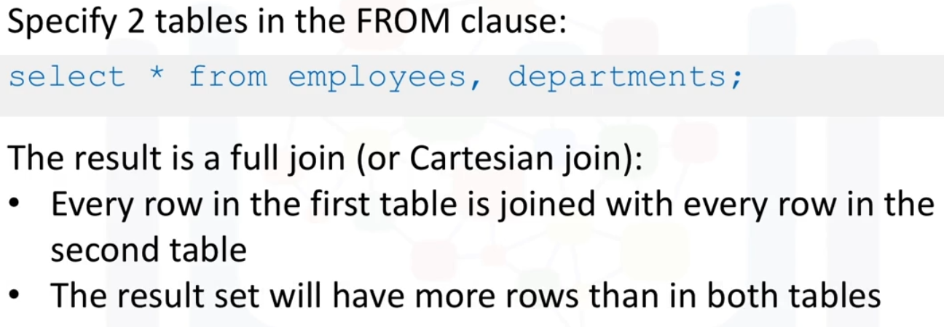  
    
  We can limit the results in the previous example with the **where** clause.  
  **cross** join or **cartesian** product **+** **where** clause equals to implicit **inner** join.
* We can give aliases to tables in the **From** clause, we use a space after table name and enter alias. Table names are separated by **commas**. This is also true for **columns**. We can also use the **AS** keyword to create aliases.  
    
  Syntax:   
  **From** table1 Alias1, table2 alias2  
    
  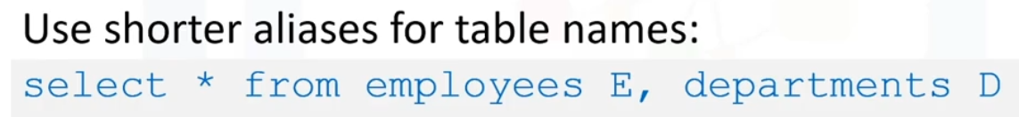
* When accessing multiple tables, we might want to use **columns** in a **query** that have the same name but in different **tables**. Using these column names in the **query** is an issue. We use this syntax when using multiple tables in a **query**:  
  Syntax:   
  Table_name**.**column_name  
    
  #we just use a prefix(table name) and **dot**(**.**)  
  Example:   
  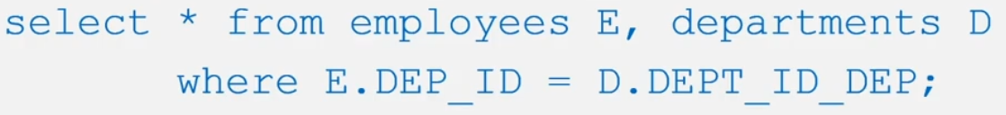
* The column names in the **select** clause can also be **prefixed** by aliases(table aliases) as shown in the **query**.  
  Example:   
  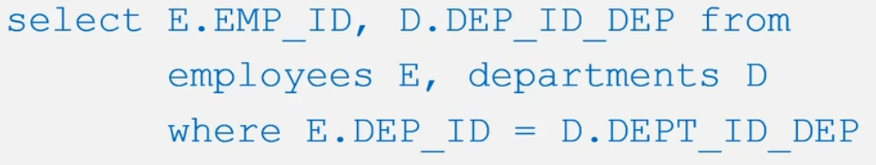
* **DB-API**: There is a mechanism by which the **Python code** communicates with the **DBMS**. The **Python code** connects to the database using **DB-API** calls. **DB-API** is **Python's** standard API for accessing relational databases. It is a standard that allows you to write a single program that works with multiple kinds of relational databases instead of writing a separate program for each one.  
  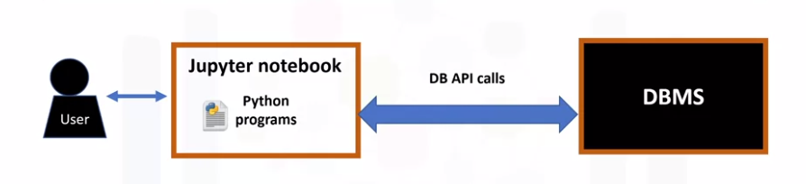
* The **application program**(in python) begins its database access with one or more **API** **calls** that connect the program to the **DBMS**.

-Then to send the SQL statement to the **DBMS**, the program builds the statement as a text string and then makes an **API call** to pass the contents to the **DBMS**.

-The **application program** makes **API calls** to check the status of its **DBMS** request and to handle errors.

-The application program ends its database access with an **API** call that disconnects it from the database.  
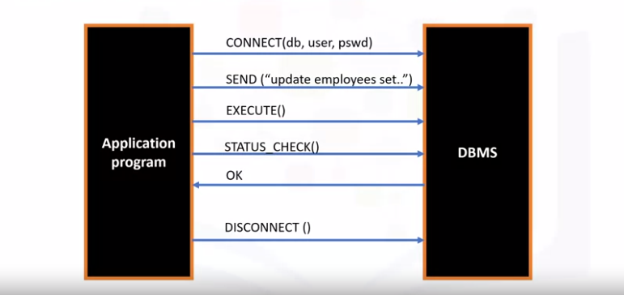

* The table shows a list of a few databases and corresponding **DB-APIs** to connect to **Python** applications.  
  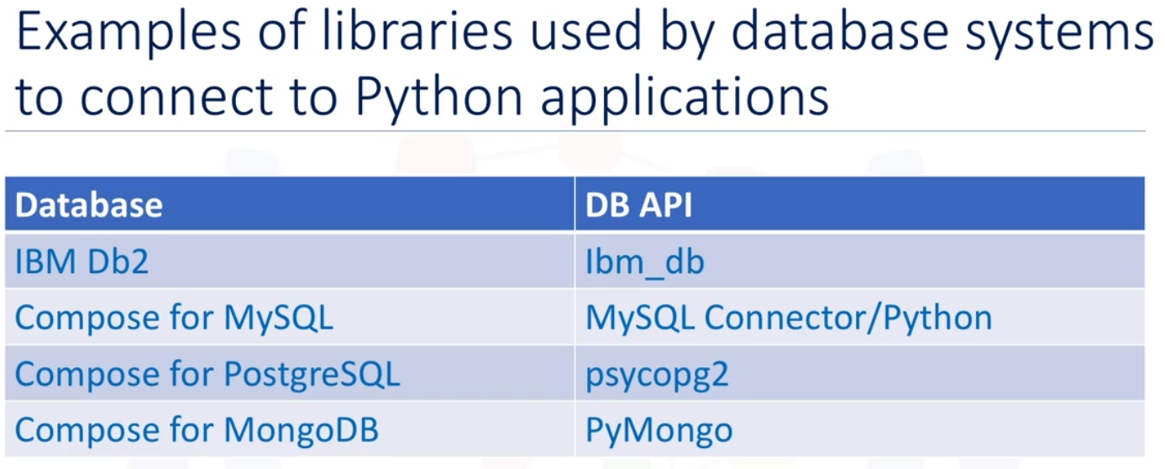
* The two main concepts in the Python **DB-API** are **connection** objects and **cursor**(query) objects. You use **connection** objects to connect to a database and manage your transactions. **Cursor** objects are used to run queries and retrieve results. You open a **cursor** object and **then** run queries. **Cursors** are also used to scan through the results of a database. **Connection** object is also called a **connection** resource.  
  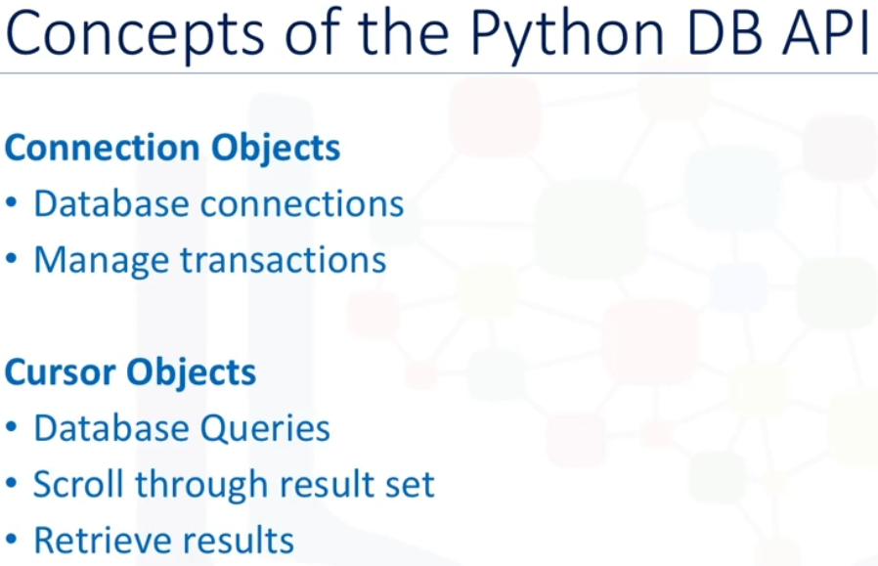
* The **DB_API** includes a **connect** **constructor** for creating a connection to the database. It returns a **Connection** Object, which is then used by the various **connection** methods. These **connection** methods are:  
   -cursor() method: which returns a new **cursor** object using the connection.  
   -commit() method: which is used to commit any pending transaction to the database.  
   -rollback() method: which causes the database to roll back to the start of any pending transaction.  
   -close() method: which is used to close a database connection.
* These are **cursor methods**, which are used to manage the **content** of a fetch operation:  
  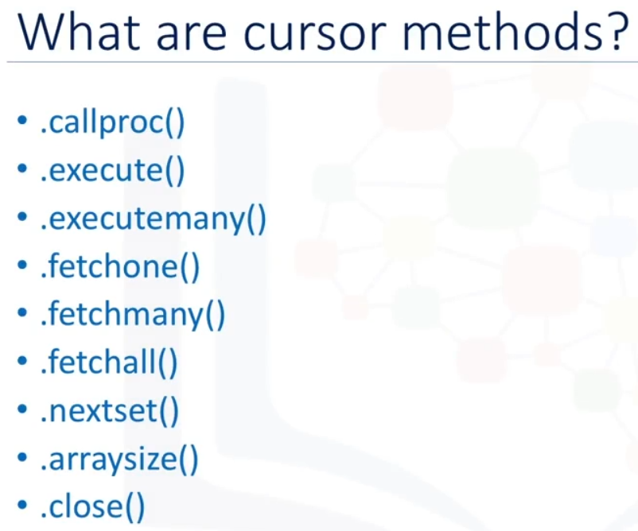
* **Cursors** created from the same **connection** are not isolated, that is, any changes done to the database by a **cursor** are immediately visible by the other **cursors**. **Cursors** created from different **connections** can or cannot be isolated depending on how the transaction support is implemented.
* A database **cursor** is a control structure that enables traversal(پیمایش) over the records of result set in a database. It behaves like a file object or file handle in a programming language. Just as a program **opens** a file to access its contents, it opens a **cursor** to gain access to the query results. Similarly, the program closes a file to end its access and closes a **cursor** to end access to the query results. Another similarity is that just as file handle keeps track of the program's current position within an open file, a **cursor** keeps track of the program's current position within the **query** results.  
  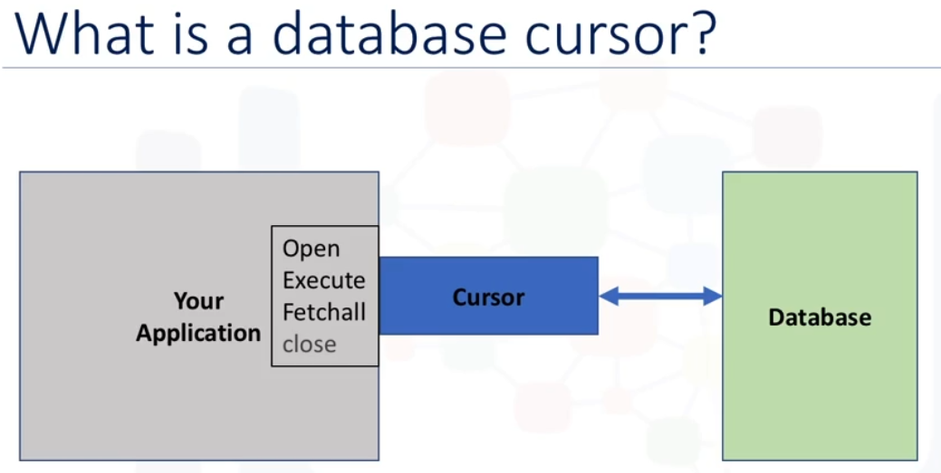
* **Cursors** can be used as context managers: leaving the context will close the cursor.  
  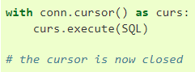
* Let's walk through a **Python application** that uses the **DB-API** to **query** a database. -First, you **import** your database module(database API module) by using the connect API from that module. To open a connection to the database, you use the **connect constructor** and pass in the parameters, that is, the database name, username, and password. The **connect** function returns a **connection** object.   
  -After this, you create a **cursor** object on the **connection** object. The **cursor** is used to run queries and fetch results.   
  -After running the queries, using the **cursor**, we also use the same **cursor** to fetch the results of the query.   
  -Finally, when the system is done running the queries, it frees all resources by **closing** the **connection**. Remember that it is always important to **close** connections to avoid unused connections taking up resources.   
  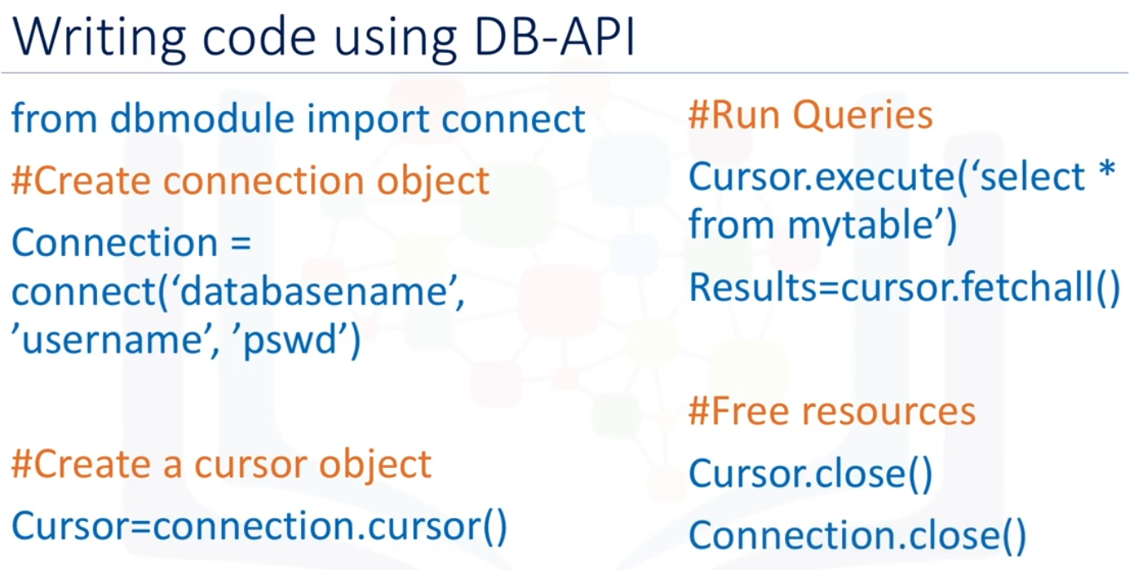
* To prepare and execute a single SQL statement, use the **ibm_db.exec_immediate** function. To avoid the security threat of SQL injection attacks, use the **ibm_db.exec_immediate** function only to execute **SQL** statements that are composed of static strings. Interpolation of Python variables representing user input into the **SQL** statement can expose your application to **SQL** injection attacks.  
  Before you begin, Obtain a **connection** resource by calling one of the **connection** functions in the **ibm_db** API.  
  To prepare and execute a single SQL statement, call the **ibm_db.exec_immediate** function, passing the listed arguments:  
  Syntax:   
  **ibm_db.exec_immediate**(connection, sql statement, options)  
    
  Connection: A valid database **connection** resource that is returned from the **ibm_db.connect** or **ibm_db.pconnect** function  
    
  SQL Statement**:** A **string** that contains the **SQL** statement. This **string** can include an XQuery expression that is called by the XMLQUERY function.  
    
  **Options:** A **dictionary** that specifies the type of **cursor** to return for result sets. You can use this parameter to request a scrollable **cursor** for database servers that support this type of **cursor**. By default, a forward-only **cursor** is returned.  
    
  If the function call **fails** (returns False), you can use the **ibm_db.stmt_error** or **ibm_db.stmt_errormsg** function to retrieve diagnostic information about the error.

If the function call succeeds, you can use the **ibm_db.num_rows** function to return the number of rows that the **SQL** statement returned or affected. If the **SQL** statement returns a result set, you can begin fetching the rows.

Examples:   
  
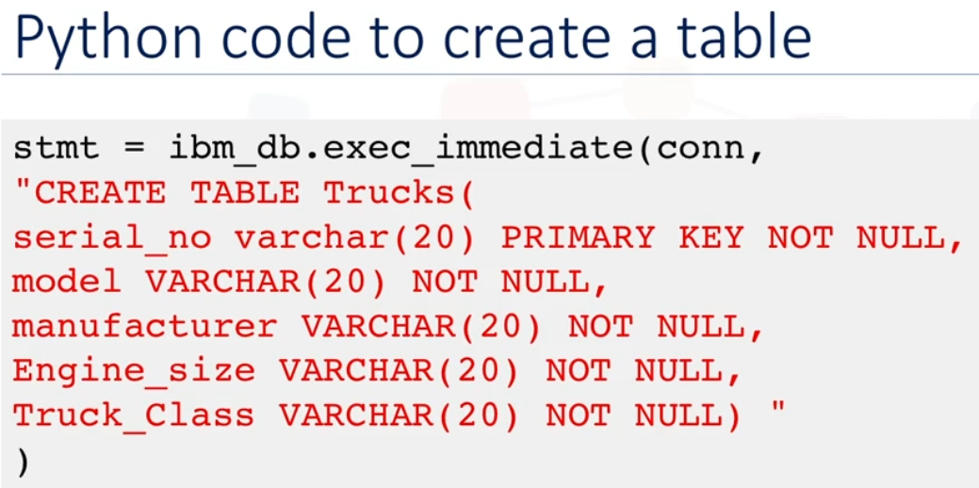  
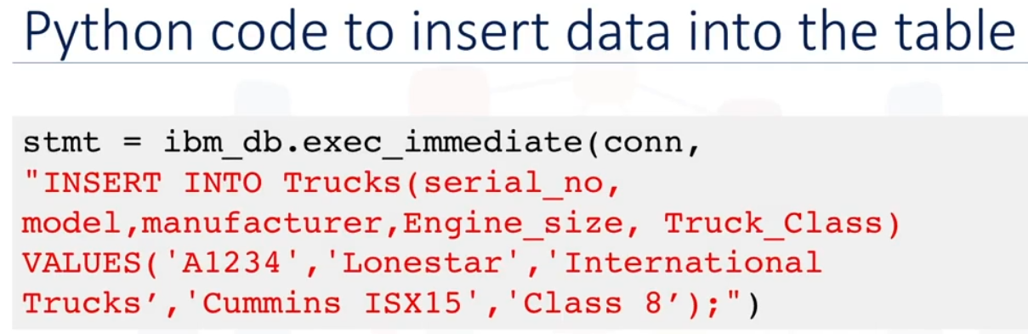

* Fetching rows or columns from result sets in Python using **ibm_db** API:  
  After executing a statement that returns one or more result sets, use one of the functions available in the **ibm_db** API to iterate through the returned rows. If your result set includes columns that contain large data (such as BLOB or CLOB data), you can retrieve the data on a column-by-column basis to avoid large memory usage.  
  Before you begin, You must have a statement resource that is **returned** by either the **ibm_db.exec_immediate** or **ibm_db.execute** function that has one or more associated result sets.  
  Fetch data from a result set by calling one of the fetch functions:  
    
  **Ibm_db.fetch_tuple:** Returns a tuple, which is indexed by column position, representing a row in a result set. The columns are 0-indexed.

**Ibm_db.fetch_assoc:** Returns a dictionary, which is indexed by column name, representing a row in a result set.

**Ibm_db.fetch_both:** Returns a dictionary, which is indexed by both column name and position, representing a row in a result set.

**Ibm_db.fetch_row:** Sets the result set pointer to the next row or requested row. Use this function to iterate through a result set. Returns **true**.  
  
Syntax: **Ibm_db.fetch_both**(Statement)  
  
These functions accept the listed arguments:

Statement: A valid statement resource. **ibm_db.exec_immediate** or  
 **ibm_db.execute** output.

Row_number: The number of the row that you want to retrieve from the result set. Specify a value for this parameter if you requested a scrollable **cursor** when you called the **ibm_db.exec_immediate** or **ibm_db.prepare** function. With the default forward-only **cursor**, each call to a fetch method returns the next row in the result set.  
  
[Read more](https://www.ibm.com/docs/en/ias?topic=SSHRBY/com.ibm.swg.im.dbclient.python.doc/doc/t0054388.htm)

* We can read **SQL** query or database **table** into a **DataFrame:  
  Syntax:**pandas**.read_sql**(sql, con)  
    
   Parameters:  
    
  Sql**: string** contains query to be executed or a table name  
  con: **connection** object  
    
  با استفاده از این تابع می توان یا **کوئری** زد یا **اسم جدول** را داد تا پایتون آن را بخواند و به **دیتافریم** تبدیل کند. برای **پاندا** باید کانکشن آبجکتی که قبلا داشتیم را با این متد به کانکشن جدید تبدیل کنیم   
    
  **ibm_db_dbi** is needed to provide high level DB-API 2.0 to support **Pandas**. We use connection object ( con ) in pandas**.read_sql**:  
    
   con=ibm_db_dbi.**Connection**(conn)  
    
  parameters: Conn is a connection object that is returned from **ibm_db.connect** or **ibm_db.pconnect** function.

The correct syntax is:   
  
con=ibm_db_dbi.**Connection**(conn)  
pandas**.read_sql**(sql, con)  
  
[Read more](https://pandas.pydata.org/docs/reference/api/pandas.read_sql.html)

* **Ibm_db** and **ibm_db_dbi** are both **API**s for ibm databases. We can **import** both in python. They are almost the same.
* ipython-sql is a %sql magic for python. This is a magic extension that allows you to immediately write SQL **queries** into code cells and **read** the results into pandas **DataFrames**. Using this, we can connect to any database which is supported by SQLAlchemy. **Magic** is JupyterLab's term for special **commands** that start with **%**.  
  to load the SQL module in the notebook we use: %load_ext sql   
  Now, with the use of %sql magic, you can use SQL **queries** directly in Jupyter Notebook.
* Jupyter notebooks have a concept of **Magic** commands that can simplify working with Python, and are particularly useful for data analysis. Your notebooks can have two types of **magic** commands:

**-Cell magics**: start with a double %% sign and apply to the entire cell

**-Line magics**: start with a single % (percent) sign and apply to a particular line in a cell

Their usage is of the format:

syntax:

**%**magic_name arguments

So far in the course you learned to access data from a database using the Python DB-API (and specifically ibm_db). With this **API,** execution of queries and fetching their results involves multiple steps. You can use the SQL Magic commands to execute queries more easily.

For example if you want to execute the a **query** to select some data from a table and **fetch** its results, you can simply enter a command like the following in your Jupyter notebook cell:

Syntax:

**%sql** select * from tablename

Although **SQL magic** simplifies working with databases, it has some limitations. For example, unlike DB-API, there are no explicit methods to close a connection and free up resources.

* **SQLite** is a **C** library that provides a lightweight disk-based (local) database that doesn’t require a separate server process. Some applications can use **SQLite** for internal data storage.

to **create** a new database and **open** a database connection to allow sqlite3 to work with it we use syntax below. sqlite3**.connect()** to create a connection to the database database_name**.db** in the current working directory, implicitly creating it if it does not exist:  
Syntax:   
**import** sqlite3

con = sqlite3**.connect**("database_name**.db**")  
cur = con**.cursor()**Con is a **connection** object that represents the connection to the on-disk database. cur is a **cursor** object. We use **.db** as file format for **sqlite** database.

* After connecting to an existing database in **sqlite**, we connect **sqlite** to **sql magic.**First we create a **connection** and **cursor** object: **import** sqlite3

con = sqlite3**.connect**("database_name**.db**")  
cur = con**.cursor()**Then connect **sqlite** to **sql magic:**Syntax: %sql sqlite://database_name.db  
  
#where DatabaseName(parameter above) will be your **.db** file

* We can connect **SQL magic** to **cloud** databases too. We just need to use the proper **API** and connect **sql magic** to that **cloud** database. Literally we can connect **sql magic** to both **local** and **cloud** databases, we just need their **API** to connect to them.
* We can connect **mysql** to sql magic: [here](https://gist.github.com/ttadesusi/69224203c01ff107f735d66496bf26a2)
* You can use python **variables** in your **SQL** statements(in **sql magic**) by adding a "**:**" prefix to your python **variable names**.  
  **%sql** **select** * **from** table **where** country = **:**country
* You can use the normal python assignment syntax to assign the results of your **queries** to **python variables**. It returns a **sql query result** object.  
  می توانیم نتیجه **کوئری** را در یک **متغیر پایتون** بریزیم  
  result = **%sql** **select** * **from** table  
  نتیجه به شکل(ظاهر) **دیتافریم** خواهد بود ولی تایپ(نوع) آن **دیتافریم** نیست   
  Result **data type**: sql.run.ResultSet  
    
  -For multi-line query you need to use << syntax:  
  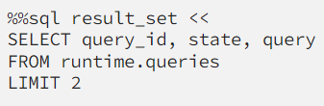
* You can easily convert a SQL **query** result to a pandas **dataframe** using the **DataFrame()** method. **Dataframe** objects are much more versatile than **SQL query result** objects. **SQL query result** objects have a method called **.DataFrame()**:  
  Example:   
  result = **%sql** **select** * **from** table  
  result.**DataFrame()** # converts **result** to a DataFrame
* **Views** in SQL are kind of virtual tables. A **view** also has rows and columns as they are in a real table in the database. We can create a **view** by selecting fields(columns) from one or more tables( or even other views) present in the database. A **View** can either have all the rows of a table or specific rows based on certain conditions. A **view** can include all or some of the columns from one or more base tables(real tables) or existing **views**.  
  Once a **view** is created, it can be **queried** like a table.  
  You can also change the data in the base table(real table) by running **insert**, **update**, and **delete** queries against the **view**.

When you define a **view**, the definition of the **view** is stored. The data that the **view** represents is stored in the base tables(real tables), not by the **view** itself.   
  
[Geeks for Geeks](https://www.geeksforgeeks.org/sql-views/)

* When to use **views**:  
  You can use a **view** to:  
   -Show a selection of data for a given table, so you can omit sensitive data like tax information, birth dates, or salaries.  
   -Combine two or more tables in meaningful ways.  
   -Simplify access to data by granting access to a view without granting access to the underlying tables.  
   -Show only the portions of data relevant to the process that uses the **view**.   
  **ویوو** بیشتر برای طبقه بندی سطح دسترسی استفاده می شود. بیشتر ویژگی های بالا همین معنی را می دهد  
    
  View usage scenario: For example, you can create a **view** that displays only non-sensitive data from the Employees table; Employee ID, name, address, job ID, manager ID, and department ID. The **view** does not show sensitive data like salary or birthdate.
* We use the **CREATE VIEW** statement to create a **view** based on one or more tables or **views**.  
    
  Syntax:  
  **CREATE VIEW** view_name (column_alias_1, column_alias_2,..,column_alias_n)

**AS SELECT** column1, column2…,column_n # **select** is accompanied by **as**

**FROM** table_name

**WHERE** condition;

* The **SELECT** statement that you use to create the **view** can name other **views** and tables, and it can use the **WHERE**, **GROUP BY**, and **HAVING** clauses. It cannot use the **ORDER BY** clause or name a host variable.
* **Views** are dynamic; they consist of the data that would be returned from the **SELECT** statement used to create them. When you use a **view** in another **SQL** statement, it behaves as though you have used a **SELECT** statement that returns the content of the **view**.  
  **ویو** آماده نیست هر بار باید بر اساس جداول اصلی محاسبه شود و بعد نمایش داده شود
* There are certain conditions needed to be satisfied to **update**(add / remove columns) a **view**. **Apparently** **Updating** a **view** is different from **updating** a table(overwriting rows with new values).  
  To **update view** we do this:  
    
  Syntax:   
  **CREATE OR REPLACE VIEW** view_name  
  **AS SELECT** column1, column2…,column_n

**FROM** table_name(s)

**WHERE** condition;  
  
[Read more](https://www.geeksforgeeks.org/sql-views/) about updating **views**

* The **WITH CHECK OPTION** clause in SQL is a very useful clause for **views**. It is applicable to an updatable(above conditions) **view**. If the **view** is not updatable, then there is no meaning of including this clause in the **CREATE VIEW** statement. when we have used the **WITH CHECK OPTION** clause in the **CREATE VIEW** statement, if the **UPDATE** or **INSERT** clause does not satisfy the conditions then they will return an error.
* Uses of a View: A good database should contain **views** due to the given reasons:

Restricting data access: Views provide an additional level of table security by restricting access to a predetermined set of rows and columns of a table.  
 Hiding data complexity: A view can hide the complexity that exists in multiple table joins.  
 Simplify commands for the user: Views allow the user to select information from multiple tables without requiring the users to actually know how to perform a join.  
Store complex queries: Views can be used to store complex queries.   
Rename Columns: **Views** can also be used to rename the columns without affecting the base tables(real table) provided the number of columns in **view** must match the number of columns specified in the **select** statement. Thus, renaming helps to hide the names of the columns of the base tables.

Multiple view facility: Different views can be created on the same table for different users.

* If you need to remove a **view** completely, you can use **DROP VIEW**:  
  Syntax:   
  **DROP VIEW** view_name;
* **Stored Procedures** are created to perform one or more **DML** operations on Database. It is nothing but the group of **SQL** statements that accepts some input in the form of parameters and performs some task and may or may not return a value. **Stored procedures** are not the same as **user-defined** **functions** in SQL but they are similar mostly.  
  به نظرم یه جورایی مثل **تابع** در **پایتون** هم هست  
  [Geeks for Geeks](https://www.geeksforgeeks.org/what-is-stored-procedures-in-sql/)
* **stored procedures** are stored and executed on the database server. Instead of sending multiple **SQL** statements from the client to the server, you encapsulate them in a **stored procedure** on the server and send one statement from the client to execute them.
* You can write **stored procedures** in many different languages. For example, for Db2 on Cloud and DB2 you can write in **SQL PL**, **PL/SQL**, **Java**, **C**, or other languages.
* The benefits of **stored procedures** include:  
  Reduction in network traffic: because only one call is needed to execute multiple statements.   
  Improvement in performance: because the processing happens on the server where the data is stored, with just the final result being passed back to the client.   
  Reuse of code: because multiple applications can use the same **stored procedure** for the same job.   
  Increase in security :  
  **a)** because you do not need to expose all of your table and column information to client-side developers and   
  **b)** you can use server-side logic to validate data before accepting it into the system.   
  Remember though, that SQL is not a fully-fledged programming language, so you should not try to write all of your business logic in your **stored procedures**.
* **Creating a Procedure**  
  Syntax for IBM:  
  **CREATE** **PROCEDURE** name(parameters)

**LANGUAGE SQL** READS / MODIFIES **SQL DATA**

**BEGIN**

//statements; #sql statements between **begin** and **end** should be separated by **;**

**END**  
  
#READS/MODIFIES SQL DATA provides other information about the **procedure** that is used when the **procedure** is called.  
#you declare the language you are using. You then enclose your **procedural logic** in the **BEGIN**….**END** statements. We separate parameters with commas **,**Examples:   
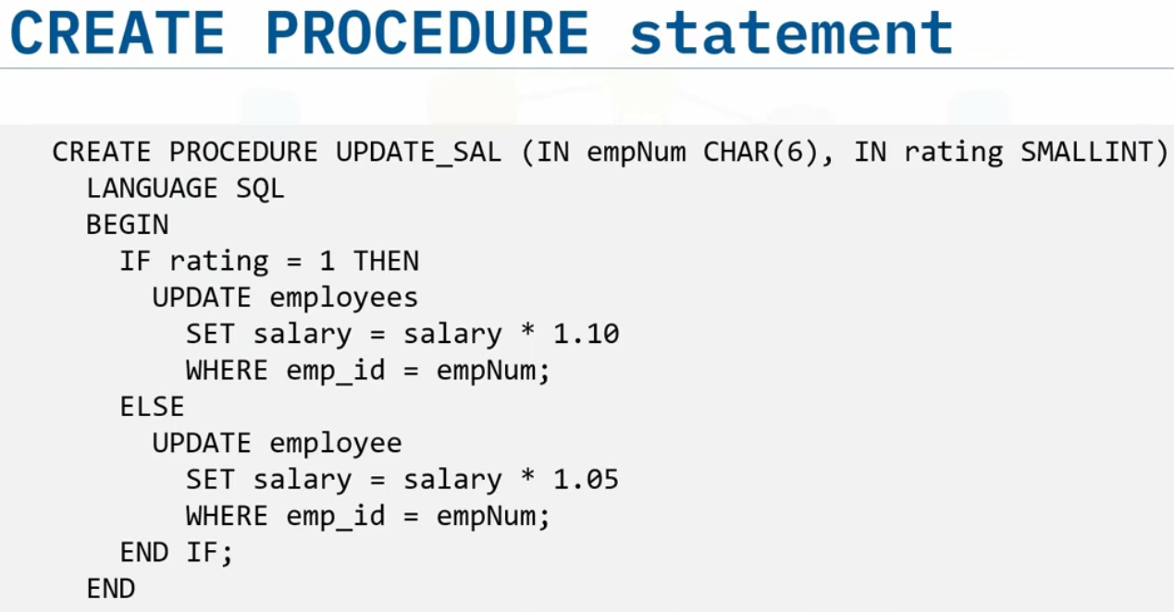  
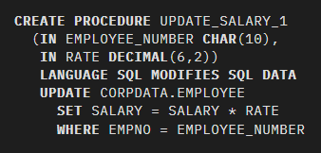  
  
The most important part is parameters. **Parameters** are used to pass values to the **Procedure**. There are 3 different types of **parameters**:  
**IN**: # input

This is the Default Parameter for the **procedure**. It always receives the values from the calling program.

**OUT**: # ouput

This parameter always sends the values to the calling program.

**IN OUT**:

This parameter performs both the operations. It Receives value from as well as sends the values to the calling program.  
  
Read more at [ibm](https://www.ibm.com/docs/en/i/7.4?topic=procedures-defining-sql-procedure)

* You can call **stored procedures** from your external applications or from dynamic **SQL** statements.
* SQL **Procedural** **Language** (**SQL PL** or **PL/SQL**) provides support for variables and flow control of statements, which can be used to control the sequence of statement execution. The commands we use in a **SQL** **procedure** like **declare** or **while** loops and… are from this language.  
  Read more at: [geeks for geeks](https://www.geeksforgeeks.org/plsql-introduction/) or [oracle](https://www.oracle.com/database/technologies/appdev/plsql.html)
* To call the **stored procedure** routine: syntax: **CALL** procedure_name;
* A **transaction** is an indivisible unit of work(کار، عمل). It can consist of **one** or **more** **SQL** statements, but to be considered successful, either all of those **SQL** statements must complete successfully, leaving the database in a new stable state, or none must complete, leaving the database as it was before the **transaction** began.  
   A **transaction** is simply a sequence of operations performed using one or more SQL statements as a single logical unit of work. **transaction** is not necessarily the smallest unit of work, it is **a** unit of work in the database. There might be smaller kinds of work. **Indivisible**: غیر قابل تقسیم، غیر قابل تجزیه  
    
  Example: a **transaction** to transfer $150 from account A to account B:

1. read(A)

2. A = A – 150

3. write(A)

4. read(B)

5. B = B + 150

6. write(B)  
  
If any of these steps fail, the whole **transaction** should fail, to keep the data in a consistent state.   
مثلا از حساب بانکی شما کم نشود ولی به حساب بانکی فروشگاه اضافه شود، این داده را از حالت کانسیستنت خارج می کند  
  
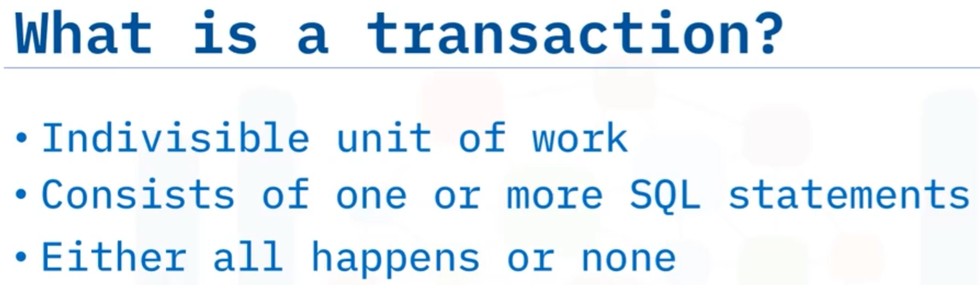

* A database **transaction**, by definition, must be **atomic**, **consistent**, **isolated** and **durable**(ACID).   
  -**Atomic**: All changes must be performed successfully or not at all.  
  -**Consistent**: Data must be in a **consistent** state before and after the transaction.  
  -**Isolated**: No other process can change the data while the **transaction** is running.   
  -**Durable**: The changes made by the **transaction** must persist.  
  These are popularly known as **ACID** properties. These properties can ensure the concurrent execution of multiple **transactions** without conflict.  
    
  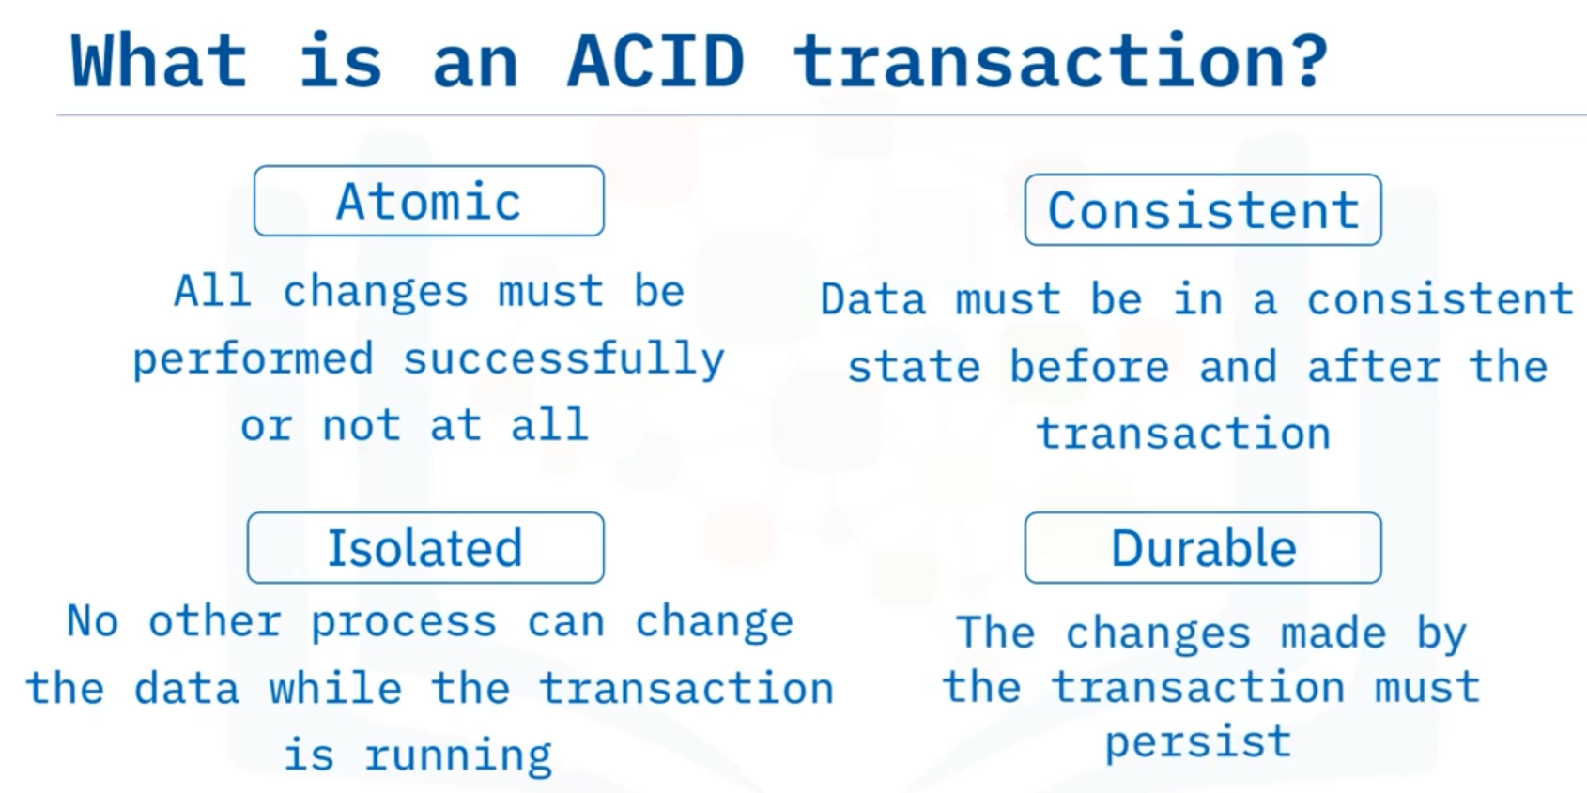  
  [Read more about ACID transaction](https://www.geeksforgeeks.org/sql-transactions/)
* ACID commands(explained below) cannot be used while creating tables and are only used with the DML Commands such as – INSERT, UPDATE and DELETE
* To start an ACID **transaction**, use the command **BEGIN**. In **db2** on Cloud, this command is implicit. Any commands you issue after that are part of the **transaction**, until you issue either COMMIT, or ROLLBACK.
* ACID command:   
  -**COMMIT**:If all the commands complete successfully, issue a **commit** command to save everything in the database to a consistent, stable state.  
   If everything is in order with all statements within a single **transaction**, all changes are recorded together in the database are called committed. The COMMIT command saves all the **transactions** to the database since the last COMMIT or ROLLBACK command (or since **begin** command).  
    
  -**ROLLBACK**: If any of the commands fail, you can issue a **rollback** command to undo all the changes and leave the database in its previously consistent stable state.  
  If any error occurs with any of the SQL grouped statements, all changes need to be aborted. The process of reversing changes is called rollback. This command can only be used to undo **transactions** since the last COMMIT or ROLLBACK command was issued.  
    
  -**SAVEPOINT**: creates points within the groups of **transactions** in which to ROLLBACK. A SAVEPOINT is a point in a **transaction** in which you can roll the **transaction** back to a certain point without rolling back the entire **transaction**.  
  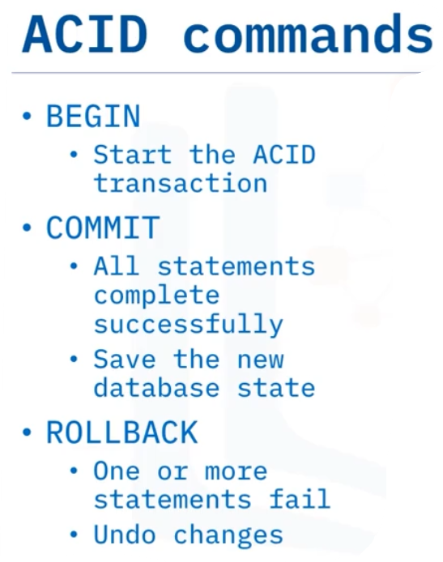
* Incorporating SQL commands into your application code gives you the opportunity to create error-checking routines that in turn control whether the **transaction** is committed or rolled back. We can also use **stored procedures** to check if a **transaction** failed or succeeded and perform either **commit** or **rollback**.(two ways: 1. Application code 2. Stored procedure)
* **TCL** means Transaction Control Language.
* A simple **Select** statement retrieves data from one or more **columns** of a single table. The next level of complexity(پیچیدگی، سختی) is retrieving data from two or more tables. This leads to multiple possibilities of how the result set can be generated. To **combine** data from two tables, you use the **JOIN** operator. A **JOIN** combines the rows from two or more tables based on a relationship between certain columns in these tables.
* When you use the **JOIN** operator, First you need to identify the relationship between tables. That is, the column or columns in each table to use as a link between the tables.
* Different types of **Joins** are as follows: **INNER** join, **LEFT** join, **RIGHT** join, **FULL** join, **NATURAL** join.  
  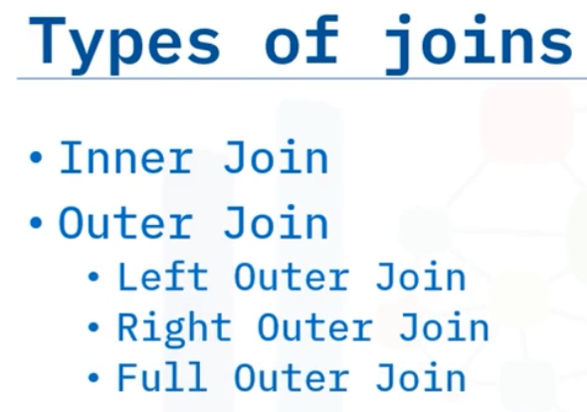
* The most common type of **join** is an **inner join**, which displays only the rows from two tables that have matching values in a common column, usually the **primary key** of one table that exists as a **foreign key** in the second table. **Inner join** is exactly the same as **Cross** join(**cartesian** product) with **where** clause.  
  فقط **سطرهای مشترک** در **دو جدول** در خروجی نمایش داده می شود  
  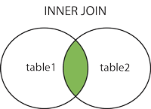
* The **INNER JOIN** keyword **selects** records(rows) that have matching values in both tables. Rows with non-matching values are not shown  
  Syntax:   
    
  **SELECT** column_name(s)

**FROM** table1 **INNER JOIN** table2

**ON** table1**.**column_name **=** table2**.**column_name;  
#In the **ON** clause, you specify the **JOIN** predicate.

* The table specified on the left of the **JOIN** clause is known as the left table. table1 is left table:   
  **FROM** table1 **INNER JOIN** table2
* The **INNER JOIN** keyword **selects** all rows from both tables as long as there is a match between the columns. If there are records(values in the common column) in one table that do not have matches in the other table, these records(rows) will not be shown!
* **Cross** join(**cartesian** product) with **where** condition is same as **inner** join. By the way, **cross** join is not the same as **full** join.
* **outer joins** return matching rows, and even the rows from one or the other table that don’t match.  
  اینر جوین فقط سطرهای مشترک را در خروجی نشان می دهد ولی همه اَوتِر جوین ها هم سطر مشترک و هم سطر غیر مشترک را در خروجی بر می گردانند  
  [Geeks for Geeks](https://www.geeksforgeeks.org/sql-join-set-1-inner-left-right-and-full-joins/)
* **Left join**: This **join** returns **all** the rows of the table on the left side of the **join** and matches rows for the table on the right side of the **join**. For the rows for which there is no matching row on the right side, the result-set will contain **null**. LEFT JOIN is also known as LEFT OUTER JOIN.  
  Syntax:  
    
  **SELECT** table1.column1,table1.column2,..., table2.column1,....

**FROM** table1 **LEFT JOIN** table2

**ON** table1.matching_column = table2.matching_column;  
  
#matching_column: Column common to both the tables  
  
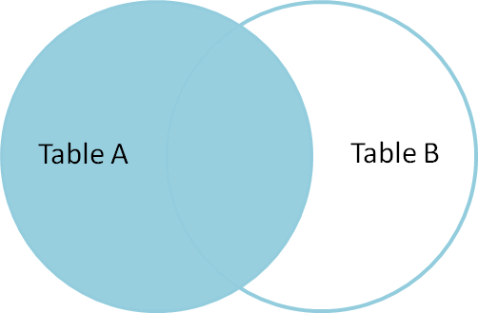  
در واقع **همه** سطر های جدول سمت چپ را نگه می داریم و از جدول راستِ **جوین،** سطرهایی که مقدار مشترک (با جدول سمت چپ) دارند را مقابل مقدار متناظر آن از جدول چپ قرار می دهیم روبروی سطرهایی از جدول سمت چپ که مقدار مشترکی وجود ندارد، **نال** قرار می دهیم

* **Right join**: RIGHT JOIN is similar to LEFT JOIN. This **join** returns **all** the rows of the table on the right side of the **join** and matching rows for the table on the left side of the **join**. For the rows for which there is no matching row on the left side, the result-set will contain **null**. RIGHT JOIN is also known as RIGHT OUTER JOIN.  
    
    
  Syntax:   
    
  **SELECT** table1.column1,table1.column2,table2.column1,....

**FROM** table1 **RIGHT JOIN** table2

**ON** table1.matching_column = table2.matching_column;  
  
#matching_column: Column common to both the tables  
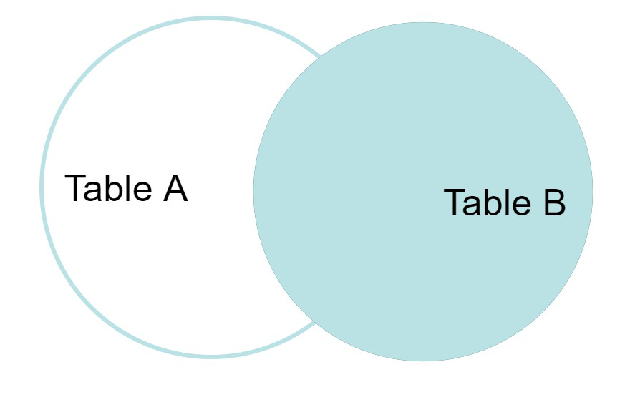

* **Full join**: FULL JOIN creates the result-set by combining results of both LEFT JOIN and RIGHT JOIN. The result-set will contain all the rows from both tables. For the rows for which there is no matching, the result-set will contain NULL values.  
  Syntax:   
    
  **SELECT** table1.column1,table1.column2,table2.column1,....

**FROM** table1 **FULL JOIN** table2

**ON** table1.matching_column = table2.matching_column;  
  
#matching_column: Column common to both the tables  
  
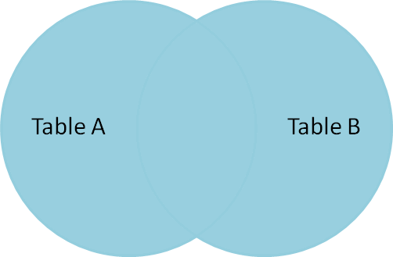

* **Natural join**: **Natural** join can join tables based on the common columns in the tables being joined. A **natural** join returns all rows by matching values in common columns having the same name and data type of columns and that column should be present in both tables. Both tables must have at least one common column with the same column **name** and same **data type**. The two tables are joined using Natural join.  
  **DBMS** will look for a common column with the same name and data type. Tuples having exactly the same values in common columns are kept in the result.
* We summarize **outer joins** here:  
  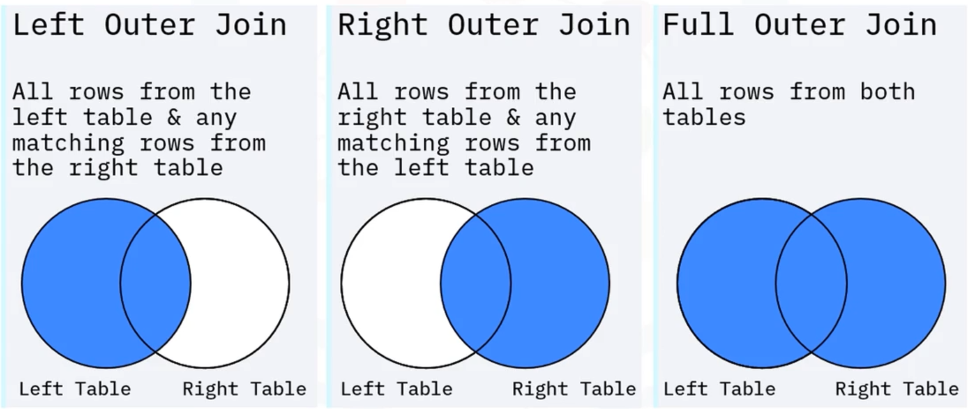  
    
  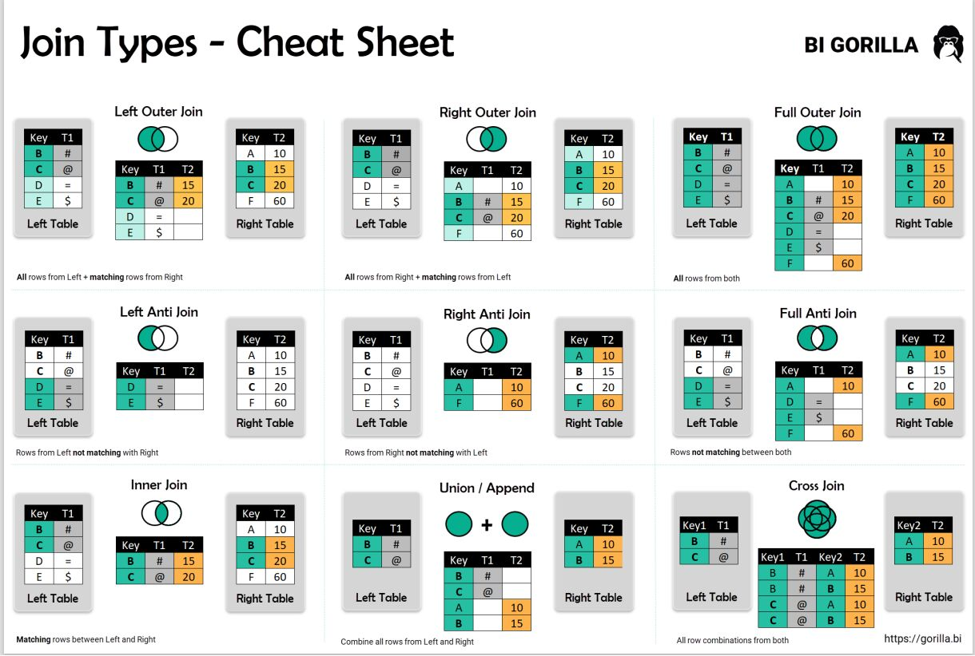
* **SELF JOIN** is a regular **join**, but the table is **joined** with itself.:  
  Syntax:   
  **SELECT** column_name(s)

**FROM** table1 T1, table1 T2

**WHERE** condition;

* We can use more than 2 tables for **joins**:  
  Example:  
  **select** f_name

**from** employees

**inner join** job_history **on** emp_id=empl_id

**inner join** jobs **on** job_ident=jobs_id  
**where** dep_id=5;

* **On** clause contains extra conditions and common column of tables.We can add more conditions by simply adding **and** in **on** clause**:**Example:

**LEFT JOIN** DEPARTMENTS **ON** DEP_ID=DEPT_ID **AND** **YEAR**(B_DATE) < 1980;  
اینجا نمی توان از **وِر** کلاز استفاده کرد چون می خوایم کل سطرهای جدول سمت چپ در خروجی بیایند ولی از جدول سمت راست فقط آن هایی که تاریخ تولد آنها قبل از 1980 است در خروجی ظاهر شوند. با استفاده از **آن** کلاز می توان روی مقادیر هر یک از ستون های جداول شرط گذاشت که کدام در خروجی بیایند و اینگونه بقیه ستون های جدول ها فیلتر نمی شوند. در صورتی که از **وِر** کلاز استفاده کنیم کل سطر یک جدول بعد از جوین شدن را فیلتر می کند

* Many of the real world datasets are made available as **.CSV** files. These are text files which contain data values typically separated by **commas**. In some cases, a different **separator** such as a **semicolon** may be used.
* The first row in the table(**.CSV** files here ) in many cases contains **attribute** labels which map to **column names** in a table.
* Note that the default **column names**(in **csv** file) may not always be database or query friendly, and if that is the case, you may want to **edit** them before the table is created.
* Let's talk about **querying** column names that are lower or mixed case, that is, a **combination** of upper and lowercase. Like Id whose ‘I’ is uppercase and ‘d’ is lowercase. Examples of mixed case names for table columns: Arrest, Beat, Block, Date(first letter of all words are capital)  
  **Querying** the Id column results in an error:  
  Example:   
  Select id from DOGS  
  to **select** data from a column with a mixed case name, we need to specify the column name in its correct case within **double quotes**: Select “Id” from DOGS  
  باید اسم ستون هایی که مخلوطی از حروف بزرگ و کوچک هستند را درست همان طور که در دیتابیس وجود دارند بین **دابل کوت** بنویسیم که **دی بی ام اس** عینا دنبال چنین نام ستونی بگردد  
    
  Ensure you use **double quotes** around the column name and **not** single quotes.
* **querying** column names that have spaces and other characters: In a **CSV** file, if the name of the column contains **spaces**, by default the database may map them to **underscores**.  
    
  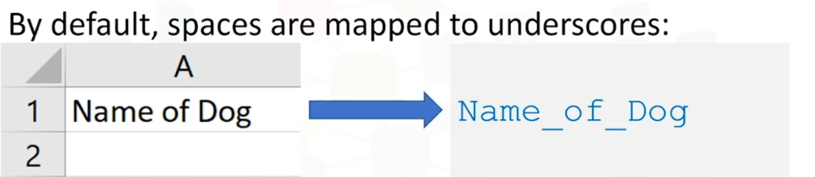  
    
  Other **special characters** like **parentheses** or **brackets** may also get mapped to **underscores**. Therefore, when you write a **query** ensure you use proper case formatting within quotes and substitute special characters to **underscores** as shown in this example.  
    
  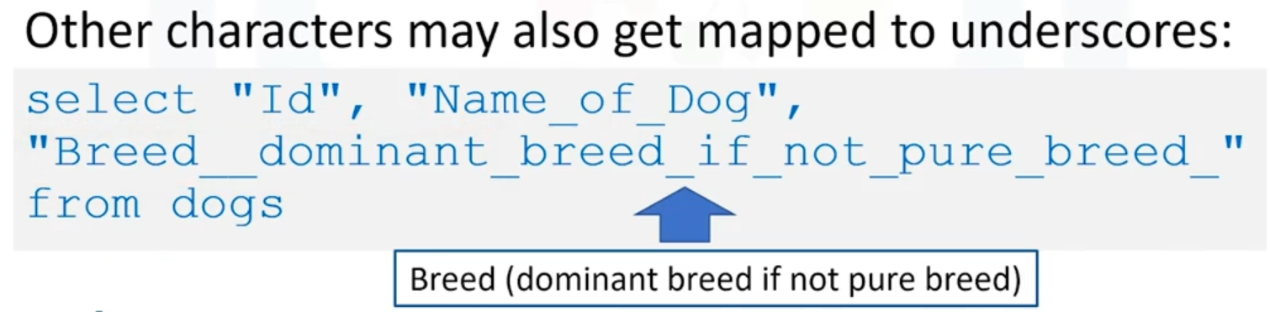  
  note the double underscore(one is for space and the other one is for parentheses ) between **breed** and **dominant** as shown. Finally, it's also important to note the trailing **underscore** after the word **breed** near the end of the query. This is used in place of the closing bracket.
* When using **quotes** in Jupyter notebooks, you may be issuing queries in a notebook by first assigning them to Python variables. In such cases, if your **query** contains **double quotes** for example, to specify a mixed case column name, you could differentiate the quotes by using **single quotes** for the Python variable to enclose this SQL query and **double quotes** for the column names.  
    
  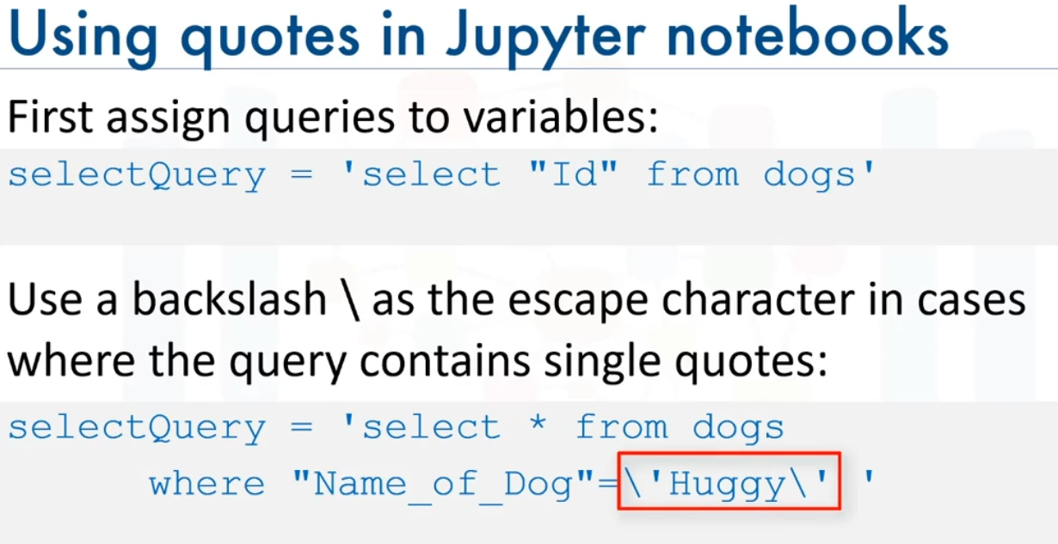
* If you have very long queries such as **join** queries or **nested** queries, it may be useful to split the query into multiple lines for improved readability. In Python notebooks, you can use the **backslash** character to indicate continuation to the next row   
  **\** : یعنی بقیه در خط بعدی   
  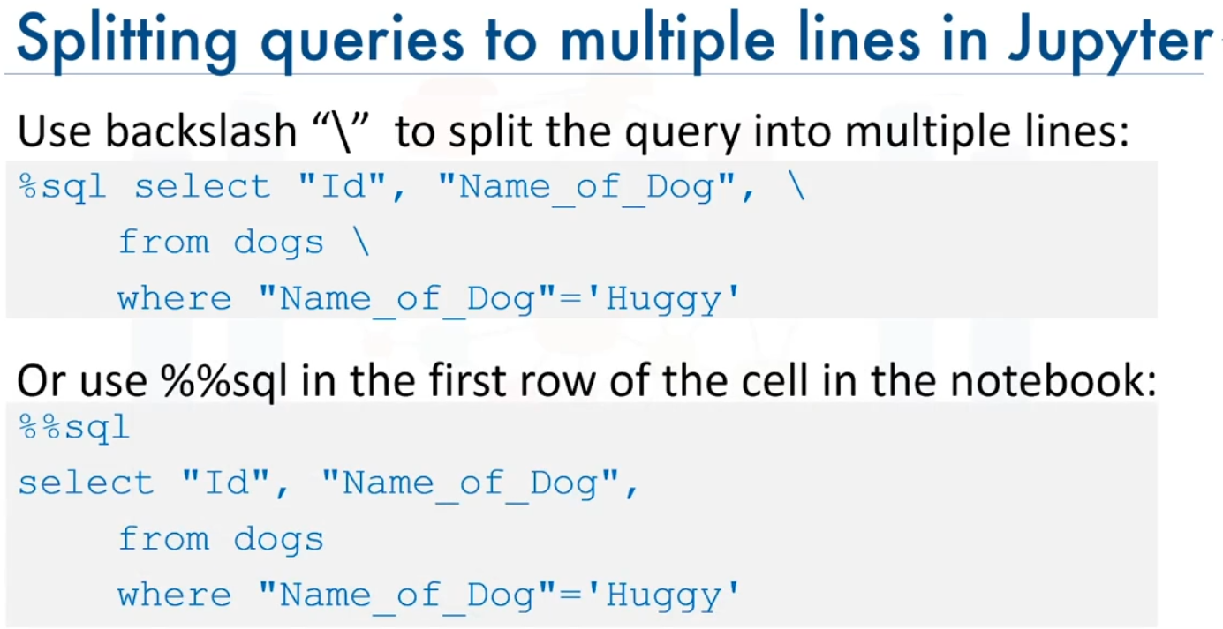  
  When using **%% sql** the **backslash** is not needed at the end of each line.
* you can **restrict** the results set by using the **limit** clause.  
    
  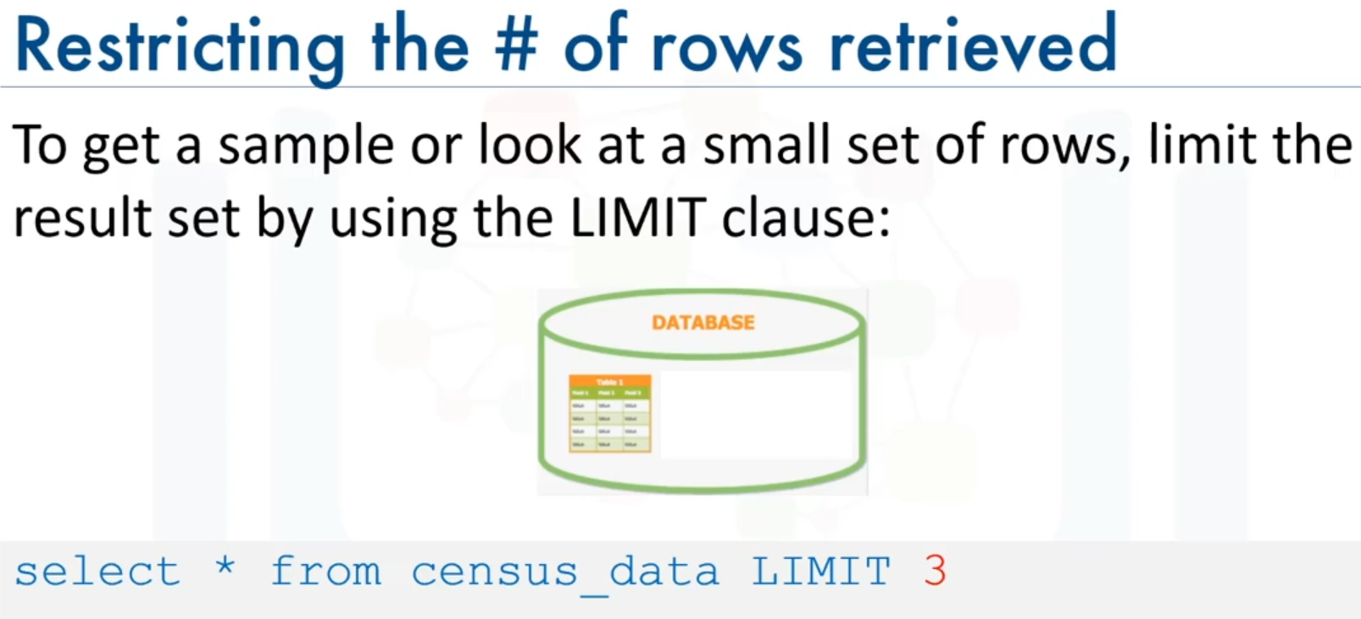
* Sometimes your database may contain several tables, and you may not remember the correct name. For example, you may wonder whether the table is called **dog**, **dogs** or **four legged mammals**. Database systems typically contain system or catalog tables, from where you can **query** the list of tables and get their properties.  
  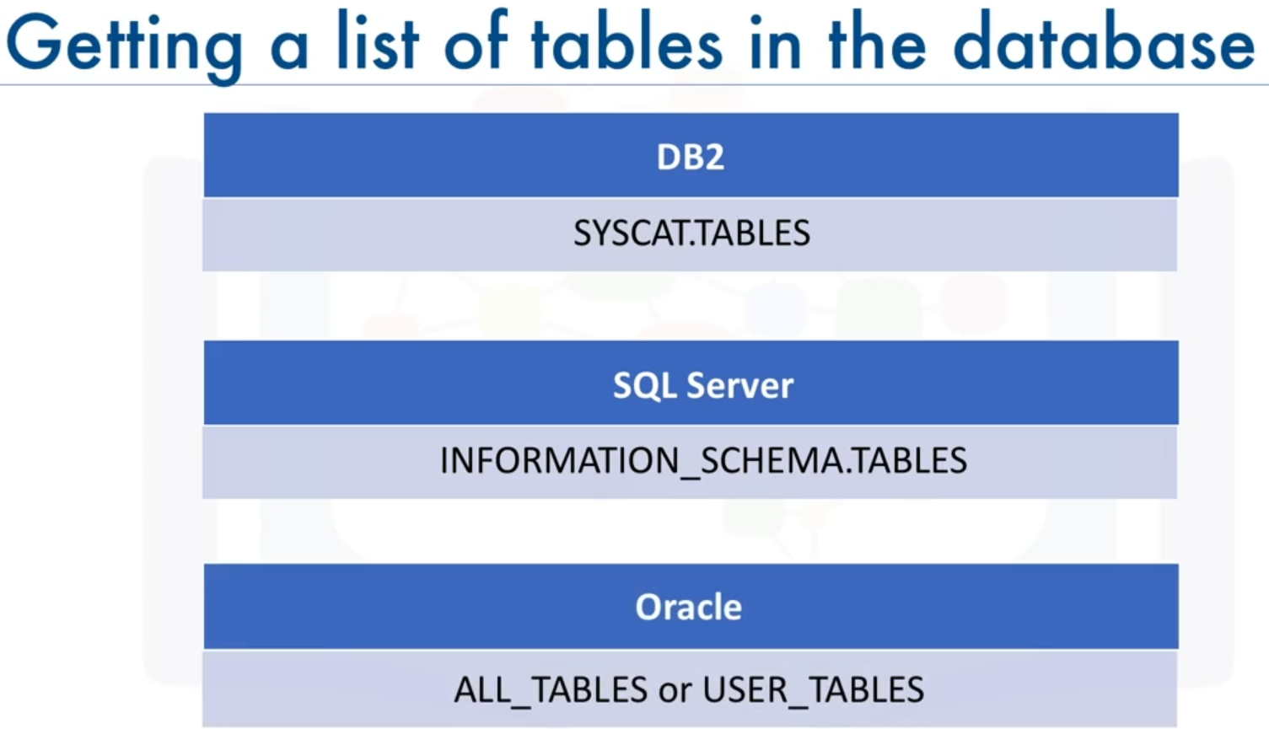  
  MySQL syntax : **show** tables
* To get a list of tables in a DB2 database, you can run the following **query:  
    
  Select** * **from** syscat.tables  
    
  This **select** statement will return too many tables including system tables, so it's better to filter the result as shown here:  
  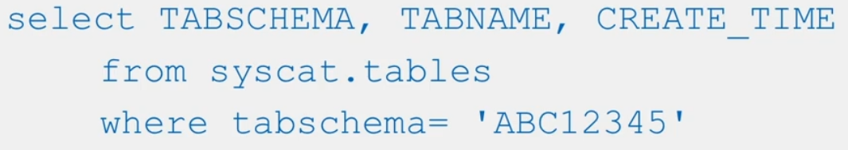  
  we replace ABC12345 with your own DB2 **username**.
* Let's talk about how to get a list of **columns** in a table. If you can't recall the exact name of a column for example, whether it had any lowercase characters or an underscore in its name, in **DB2** you can issue a **query** like the one shown here:  
  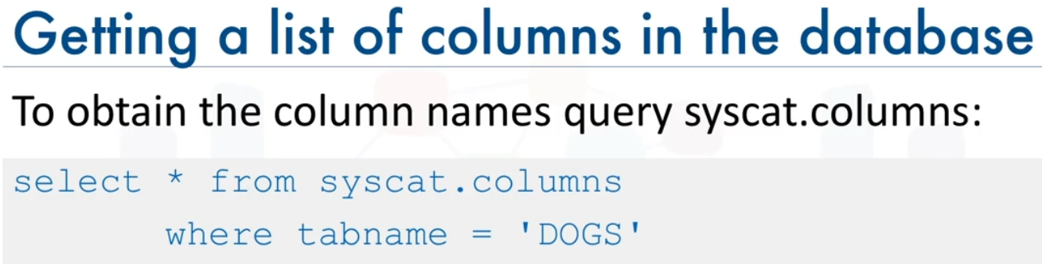  
  in **MYSQL**, you can simply run the command to retrieve column names for dog table:   
  Example:   
  **show** columns **from** dogs
* If we want to know specific properties of columns like the data type and length of the data type in db2:   
  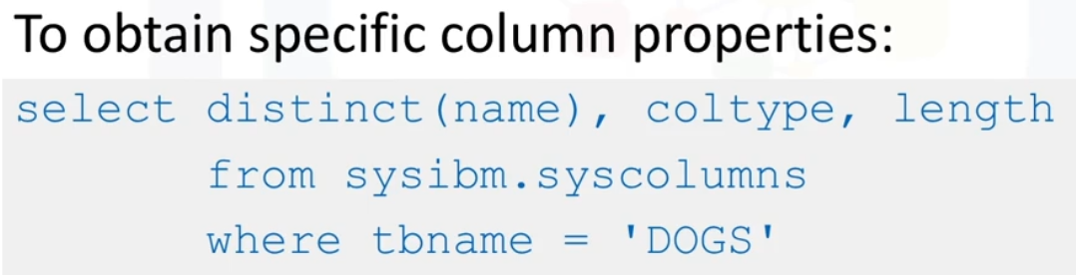
* In **sqlite** the system catalog table called **sqlite_master** contains the table metadata:  
  # returns list of tables  
  Syntax: %sql **SELECT** name **FROM** sqlite_master **WHERE** type='table'
* In **sqlite** the, we can access column names and types and other information related to a table:  
  **Select** * **from** PRAGMA_TABLE_INFO('table_name')  
    
  # table_name must be a **string (**enclosed in **single quotes**)
* The REPLACE() function **replaces** all occurrences of a substring within a string in each row of a column, with a new substring. beware The search is case-insensitive.  
  Syntax:   
  **SELECT** **REPLACE**(column_name, old_string, new_string );  
  #This is a **sql** function not a python function.
* The **CAST()** function is used for converting a value from one data type to another specific data type. The **CAST()** function accepts two parameters which are the value to be converted and the data type to which the value needs to be converted. We can use it in the **where** clause or in the **select** statement.  
  Syntax:   
  **CAST**(column_name **AS** destination_data_type)  
  Example 1:   
  **SELECT** **CAST**(column_name AS int);  
    
  Example 2:   
  **where** **CAST** (column_name **AS** DOUBLE ) < 70
* Read about **Grouping sets** clause in data warehouse document page 34
* A **Common Table Expression** (CTE) is a construct used to temporarily store the result set of a specified query such that it can be referenced by subsequent queries. The result of a CTE is not persisted on the disk but instead, its lifespan lasts till the execution of the query (or queries) referencing it. CTE is the result set of a query which exists temporarily and for use only within the context of a larger query. Much like a derived table, the result of a CTE is not stored and exists only for the duration of the query. A CTE only exists for the duration of the statement of which it's a part (of).  
  یک بار مصرف است و عُمر آن فقط به اندازه یک کوئری داوم دارد ولی در همان یک کوئری می توان چندين بار به آن رفرنس زد
* Basically, when your FROM clause lists tables like so:  
  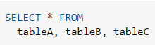  
  The result is a **cross product**(cartesian product) of all the rows in tables A, B, C. Then you apply the restriction WHERE tableA.id = tableB.a_id which will throw away a huge number of rows, then further ... AND tableB.id = tableC.b_id and you should then get only those rows you are really interested in.  
  DBMSs know how to optimize this SQL so that the performance difference to writing this using JOINs is negligible (if any). Using the JOIN notation makes the SQL statement more readable (IMHO, not using joins turns the statement into a mess). Using the cross product, you need to provide join criteria in the WHERE clause, and that's the problem with the notation. You are crowding your WHERE clause with stuff like  
  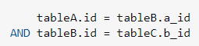  
  which is only used to restrict the cross product. WHERE clause should only contain RESTRICTIONS to the resultset. If you mix table **join** criteria with resultset restrictions, you (and others) will find your query harder to read. You should definitely use JOINs and keep the FROM clause a FROM clause, and the WHERE clause a WHERE clause.
* In Python, the %s placeholder is used to dynamically insert values into a SQL query string. This helps to prevent SQL injection attacks, which can occur when malicious user input is directly embedded into the SQL query. By using placeholders, the query remains secure as the values are not directly embedded, but rather substituted later when the query is executed. Variables are specified either with **positional** %s or **named** %(name)s placeholders. [link](https://www.psycopg.org/docs/usage.html#query-parameters)  
  Example:   
  sql = "insert into car_table values(%s,%s,%s,%s)" # SQL command string  
  result = cursor**.execute**(sql, (timestamp, vehcile_id, vehicle_type, plaza_id))  
  
* When the **view** is complex, requested frequently, or is run on large data sets, consider materializing the view to help reduce the load on the database.
* Materialized query tables (MQTs) are tables whose definition is based on the result of a query. The data consists of precomputed results from the tables that you specify in the materialized query table definition. MQTs are classified by how their data is maintained. [ibm](https://www.ibm.com/docs/en/db2-for-zos/11?topic=rewrite-creating-materialized-query-table)